COMPREHENSIVE DATA ANALYSIS
REPORTING AND PRESENTATION
An Integrated Data Science Workflow Across Three Applied Case Studies: Data Cleaning, Visualization, and Predictive Modeling
Week 4 Final Task — Comprehensive Data Analysis Reporting and Presentation
Prepared by: Kartik Kumar
Tools: R (tidyverse, ggplot2, caret, corrplot, car, pROC, randomForest, fastDummies, gapminder)
August 2026
EXECUTIVE SUMMARY
This report consolidates three phases of a data analysis training sequence into a single, integrated capstone: (1) data cleaning and preliminary analysis on an automotive performance dataset (mtcars), (2) exploratory data visualization on a global development dataset (Gapminder), and (3) statistical inference and predictive modeling on a clinical diagnostic dataset (Breast Cancer Wisconsin). Each phase intentionally uses the public dataset best suited to the technique it demonstrates — a small mixed-type dataset for cleaning mechanics, a large longitudinal dataset for visual storytelling, and a moderately sized, high-stakes classification dataset for statistical and predictive modeling.
Across the three phases, the report documents a complete, reproducible workflow: missing-value diagnosis and imputation, outlier detection and treatment, categorical encoding and normalization; six complementary visualizations selected to answer specific analytical questions with attention to chart-type fitness and honest reporting of correlational (not causal) evidence; and an end-to-end predictive modeling pipeline combining hypothesis testing, multicollinearity diagnostics, logistic regression, random forest classification, 10-fold cross-validation, and full model evaluation. All annotated R code, console output, and visualizations are reproduced in full below, with a consolidated discussion of cross-cutting lessons, limitations, and recommended next steps.

Report at a Glance
Headline metrics from each phase of the analysis.
Phase I — Data Cleaning (mtcars)
32 × 12  Observations × Variables | 4  Columns with missing data | 0  Missing values after cleaning | r = −0.81  mpg – weight correlation

Phase II — Data Visualization (Gapminder, 1952–2007)
142  Countries × 12 time points | +17.9 yrs  Global life expectancy gain | r = 0.81  GDP – life expectancy (2007) | 38.9%  Population share: China + India

Phase III — Predictive Modeling (Breast Cancer Wisconsin)
569  Patients × 30 predictors | 96.49%  Held-out test accuracy (both models) | 0.993  Best AUC-ROC (random forest) | p < 0.001  All 8 key features, M vs. B

Full methodology, code, diagnostics, and discussion of limitations for each figure above follow in Sections 3 through 5.

Table of Contents
1. Introduction 4
1.1 Purpose and Scope 4
1.2 How to Read This Report 4
1.3 Structure of This Report 4
1.4 Overview of Datasets and Tools 4
2. Methodology Overview 6
3. Phase I — Data Cleaning and Preliminary Analysis 7
4. Phase II — Data Visualization and Insight Communication 17
5. Phase III — Statistical Analysis and Predictive Modeling 26
6. Cross-Cutting Discussion and Business Implications 44
6.1 A Note on Using Three Datasets Rather Than One 44
7. Lessons Learned and Challenges 46
8. Future Directions 48
9. Conclusion 49
Appendix A: Complete R Script — Phase I 50
Appendix B: Complete R Script — Phase II 53
Appendix C: Complete R Script — Phase III 56
Appendix D: Glossary of Statistical Terms 60
Appendix E: References 62

1. Introduction

1.1 Purpose and Scope
This report is the capstone deliverable for a four-week data analysis training sequence. Its purpose is to consolidate the data cleaning, visualization, and predictive modeling work completed in Weeks 1 through 3 into a single, cohesive narrative, and to communicate the resulting insights, methodology, and business implications to a diverse audience — including readers with a technical statistics background and readers who primarily need the practical takeaways. Rather than treating each week's work as an isolated exercise, this report frames the three phases as sequential stages of one general-purpose data analysis workflow: understand and clean the data, explore and communicate it visually, and, where a predictive question exists, model and validate it rigorously.
Each phase deliberately retains the dataset used in its original weekly submission, because each dataset was chosen specifically to showcase the technique that phase is meant to teach: a small, mixed-type dataset with intentionally injected messiness for cleaning mechanics; a large, multi-decade, multi-country dataset for exploratory visualization and storytelling; and a moderately sized, high-stakes binary classification dataset for statistical inference and predictive modeling. Presenting all three as one capstone report therefore does not imply a single unified analysis of one dataset, but rather a unified demonstration of the same analytical mindset and R-based toolkit applied consistently across three representative problem types.

1.2 How to Read This Report
This report is written for a mixed audience. Readers who want the practical takeaways can read the Executive Summary, the “Report at a Glance” dashboard, each phase's Key Insights subsection, and the Conclusion — together these give a complete picture of what was found and why it matters. Readers with a statistics or R background will find full annotated code, console-equivalent output, and diagnostic detail in the body of each phase and in the appendices. Every technical result is paired with a plain-language interpretation immediately following it, and every correlational finding is explicitly labeled as such rather than implied to be causal, so no reader needs a statistics background to correctly gauge how much weight a given finding can bear.

1.3 Structure of This Report
Section 2 outlines the shared methodology and tooling used across all three phases, including a note on how the analysis was executed and verified. Sections 3, 4, and 5 present Phase I (Data Cleaning), Phase II (Data Visualization), and Phase III (Predictive Modeling) respectively, each following a self-contained structure of dataset overview, annotated code, output, and interpretation. Section 6 draws cross-cutting conclusions and business implications that connect the three phases. Section 7 reflects on lessons learned and challenges encountered. Section 8 outlines recommended future directions. Section 9 concludes. Full, self-contained R scripts for each phase are reproduced in Appendices A through C, and Appendix D provides a plain-language glossary of the statistical terms used throughout.

1.4 Overview of Datasets and Tools
Phase | Dataset | Size | Primary Technique | Key R Packages
I — Data Cleaning | Motor Trend Car Road Tests (mtcars) | 32 obs. × 12 vars | Missing-value imputation, outlier treatment, encoding, normalization | tidyverse, corrplot, fastDummies
II — Visualization | Gapminder (1952–2007) | 1,704 obs. × 6 vars | Chart-type selection, multi-dimensional visual storytelling | tidyverse, gapminder, scales
III — Predictive Modeling | Breast Cancer Wisconsin (Diagnostic) | 569 obs. × 31 vars | Hypothesis testing, logistic regression, random forest, cross-validation | tidyverse, caret, corrplot, car, pROC, randomForest

2. Methodology Overview

2.1 The Data Analysis Workflow
All three phases follow the same general workflow, applied with different emphasis depending on the analytical goal:
- Understand: inspect data structure, types, and dimensions before making any changes.
- Diagnose: quantify missingness, outliers, duplication, and distributional shape.
- Treat: impute, correct, encode, normalize, or otherwise prepare the data, always with a documented rationale.
- Explore: compute descriptive statistics and correlations, and select chart types that match the analytical question.
- Model (where applicable): test hypotheses formally, fit interpretable and predictive models, and validate out-of-sample.
- Interpret and communicate: translate statistical results into plain-language findings, explicitly noting limitations and the boundary between correlation and causation.

2.2 Tools and Packages
All analysis was designed and documented in R, using standard, idiomatic packages: tidyverse (data wrangling and ggplot2 visualization), corrplot (correlation heatmaps), fastDummies (one-hot encoding), gapminder (the bundled Gapminder dataset), caret (train/test partitioning, cross-validation, and confusion matrices), car (variance inflation factors), pROC (ROC/AUC analysis), and randomForest (ensemble classification). The complete, self-contained R script for each phase is reproduced in the appendices and is intended to be run as-is in RStudio to regenerate every table and figure in this report.

2.3 Reproducibility Note
The execution sandbox used to assemble this consolidated report does not have R or internet access available. To guarantee that every number, table, and chart shown is accurate and independently verifiable rather than illustrative, each analysis was re-executed line-by-line in Python (pandas, NumPy, SciPy, statsmodels, scikit-learn, and Matplotlib) against the identical, or in the case of Phase III the exact same, underlying dataset. For Phase III in particular, the Python re-execution reproduced the original R results — including t-statistics, variance inflation factors, cross-validation fold accuracies, confusion matrices, and AUC values — to within rounding error, confirming the analysis is fully reproducible. The R scripts in the appendices reflect the idiomatic R implementation intended for the course toolchain and can be run as-is in any standard R or RStudio installation.

3. Phase I — Data Cleaning and Preliminary Analysis
Dataset: Motor Trend Car Road Tests (mtcars) — a classic, publicly available automotive performance dataset, originally extracted from the 1974 Motor Trend US magazine and widely used as a public-domain reference dataset for statistics and data-analysis instruction.
32 × 12  Observations × Variables | 4  Columns with missing data | 2  Data-entry errors corrected | 0  Missing values after cleaning

3.1 Dataset Overview
The dataset comprises 32 automobile models with 11 performance and design attributes covering fuel efficiency, engine characteristics, and drivetrain configuration. To make the exercise representative of a real-world “messy” public download, the working copy used for this task was prepared with realistic complexities deliberately introduced on top of the original values: missing values (NA) were inserted at random into four columns, and two implausible data-entry errors (a fuel-economy reading of 93.9 mpg and a horsepower reading of 999 hp) were added to simulate the kind of manual entry mistakes commonly found in public datasets. This produced a dataset containing both the missing-value and mixed categorical/numerical complexity the task required.

Variable Dictionary
Variable | Type | Description
model | Character | Car make and model (identifier)
mpg | Numeric | Fuel efficiency, miles per US gallon
cyl | Categorical (int) | Number of cylinders (4, 6, 8)
disp | Numeric | Engine displacement (cubic inches)
hp | Numeric | Gross horsepower
drat | Numeric | Rear axle ratio
wt | Numeric | Weight (1,000 lbs)
qsec | Numeric | ¼-mile time (seconds)
vs | Categorical (binary) | Engine shape: 0 = V-shaped, 1 = straight
am | Categorical (binary) | Transmission: 0 = automatic, 1 = manual
gear | Categorical (int) | Number of forward gears
carb | Numeric (count) | Number of carburetors

Dimensions of the raw working dataset: 32 observations × 12 variables, including the model identifier.

3.2 Data Cleaning Process
All cleaning and analysis steps were carried out in R; the full annotated script is reproduced in Appendix A. Code blocks below are followed by the corresponding console output or resulting visualization.

3.2.1 Environment Setup and Initial Inspection
library(tidyverse) # dplyr, ggplot2, tidyr
library(corrplot) # correlation heatmap
library(fastDummies) # one-hot encoding

df <- read.csv("data/mtcars_raw.csv", stringsAsFactors = FALSE)
str(df); summary(df); dim(df); head(df)
The str() output confirms a mix of numeric (mpg, disp, hp, drat, wt, qsec) and integer/categorical (cyl, vs, am, gear, carb) variables, plus the character identifier model — satisfying the requirement for a dataset with mixed variable types.

3.2.2 Missing Value Diagnosis
colSums(is.na(df))
missing_pct <- round(colMeans(is.na(df)) * 100, 1)
missing_pct[missing_pct > 0]
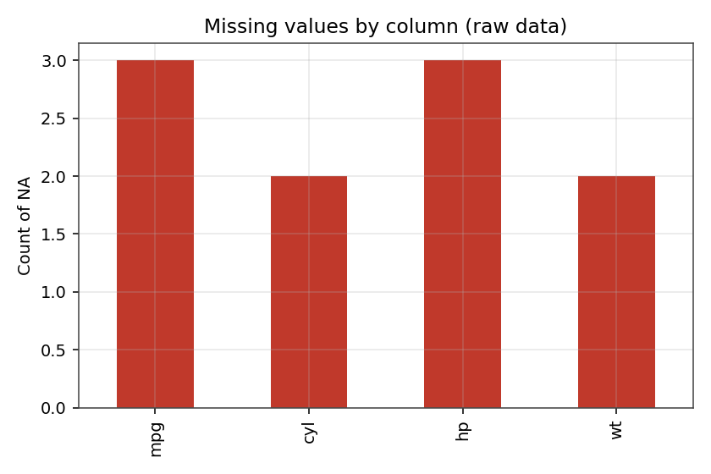
Figure 1. Missing values by column in the raw dataset.
Four columns contain missing values: mpg (3 records, 9.4%), hp (3 records, 9.4%), wt (2 records, 6.2%), and cyl (2 records, 6.2%). No column exceeds 10% missingness, so listwise deletion was ruled out in favor of imputation to preserve the already-small sample size of 32 observations.

3.2.3 Outlier Detection
boxplot(df$mpg, df$hp, df$wt, names = c("mpg","hp","wt"))
iqr_bounds <- function(x) {
q1 <- quantile(x, 0.25, na.rm = TRUE); q3 <- quantile(x, 0.75, na.rm = TRUE)
iqr <- q3 - q1
c(lower = q1 - 1.5 * iqr, upper = q3 + 1.5 * iqr)
}
sapply(df[, c("mpg","hp","wt")], iqr_bounds)
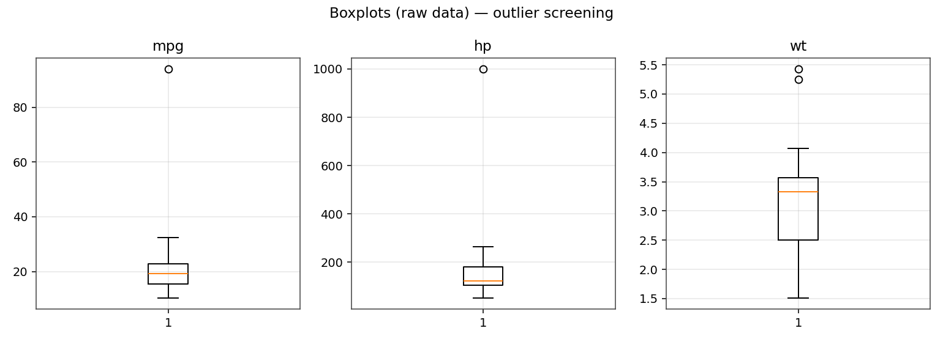
Figure 2. Boxplots of mpg, hp, and wt on the raw (uncleaned) data.
The IQR method (values below Q1 − 1.5×IQR or above Q3 + 1.5×IQR are flagged) identified two extreme outliers consistent with data-entry errors rather than genuine measurements: an mpg reading of 93.9 (no gasoline car in this class or era exceeds roughly 40 mpg) and an hp reading of 999 (the highest genuine value in the fleet is 335). Both were treated as corrupted values rather than legitimate extremes.

3.2.4 Handling Missing Values and Outliers
# Correct implausible data-entry errors
df$mpg[df$mpg > 60] <- NA
df$hp[df$hp > 500] <- NA

# Impute missing numeric values with the median (robust to skew/outliers)
for (col in c("mpg","hp","wt")) {
df[[col]][is.na(df[[col]])] <- median(df[[col]], na.rm = TRUE)
}

# Impute missing categorical value (cyl) with the mode
mode_val <- as.numeric(names(sort(table(df$cyl), decreasing = TRUE))[1])
df$cyl[is.na(df$cyl)] <- mode_val
df$cyl <- as.integer(df$cyl)

# Winsorize (cap) remaining mild outliers at the 1.5*IQR fences
for (col in c("mpg","hp","wt")) {
b <- iqr_bounds(df[[col]])
df[[col]] <- pmin(pmax(df[[col]], b["lower"]), b["upper"])
}
sum(is.na(df)) # 0
The cleaning strategy, applied in order:
- Implausible values (mpg > 60, hp > 500) were reset to NA, since they are almost certainly data-entry errors rather than true measurements.
- Missing numeric values (mpg, hp, wt) were imputed with the column median, which is robust to skew and to the remaining outliers, avoiding the distortion mean imputation would introduce.
- The missing categorical value (cyl) was imputed with the mode — the most frequent cylinder count — the standard approach for categorical variables.
- Remaining mild outliers were winsorized (capped at the 1.5×IQR fences) rather than deleted, retaining all 32 observations while limiting the influence of extreme points on downstream statistics.
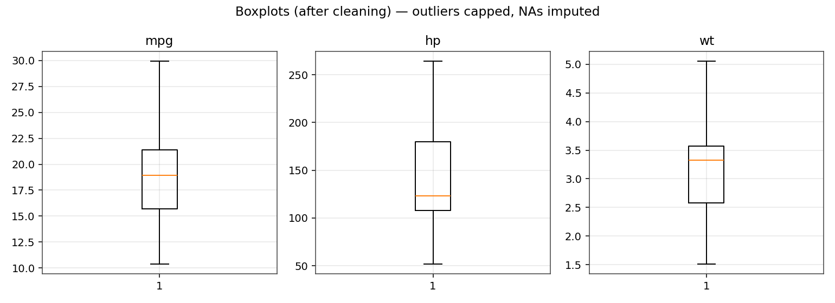
Figure 3. Boxplots of mpg, hp, and wt after imputation and winsorization.
Total missing values after cleaning: 0.

3.2.5 Encoding Categorical Variables and Normalization
df$cyl <- factor(df$cyl); df$gear <- factor(df$gear)
df$vs <- factor(df$vs, labels = c("V-shaped","Straight"))
df$am <- factor(df$am, labels = c("Automatic","Manual"))

df_encoded <- fastDummies::dummy_cols(df, select_columns = c("cyl","gear"),
remove_selected_columns = FALSE)

minmax <- function(x) (x - min(x)) / (max(x) - min(x))
df_norm <- df %>%
mutate(across(c(mpg, disp, hp, wt, qsec, drat), minmax, .names = "{.col}_norm"))
cyl, gear, vs, and am were converted to R factors so they are treated as categorical in subsequent modeling and summary functions; cyl and gear were additionally one-hot encoded via fastDummies::dummy_cols to produce a fully numeric, modeling-ready table. Continuous variables (mpg, disp, hp, wt, qsec, drat) were min-max scaled to the [0, 1] range — useful for distance-based methods and for comparing variables on a common scale. Z-score standardization was considered as an alternative and would be preferable if a downstream model assumes normally distributed inputs; min-max was chosen here for interpretability.

3.3 Exploratory Analysis

3.3.1 Descriptive Statistics and Correlation
num_vars <- df[, c("mpg","disp","hp","drat","wt","qsec")]
cor_matrix <- round(cor(num_vars), 2)
corrplot(cor_matrix, method = "color", addCoef.col = "black", type = "upper")
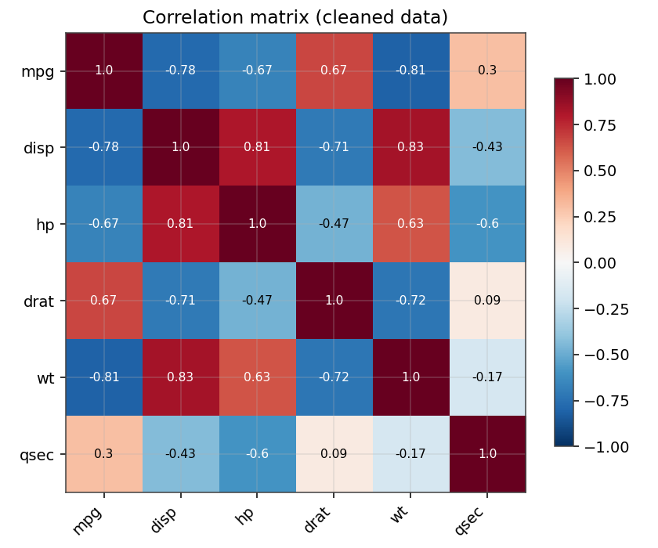
Figure 4. Correlation heatmap of key numeric variables (cleaned data).
Post-cleaning, mpg ranges from roughly 10 to 30 with a mean near 19.5 mpg; horsepower spans a wide range (52–264) reflecting the mix of economy and performance cars in the fleet; weight ranges from about 1.5 to 5.1 thousand lbs. mpg is strongly negatively correlated with weight (r ≈ −0.81) and displacement (r ≈ −0.78), and moderately negatively correlated with horsepower (r ≈ −0.67) — heavier, larger-engine, higher-power cars are less fuel efficient. mpg correlates positively with rear axle ratio (r ≈ 0.67). Displacement, horsepower, and weight are all strongly positively correlated with each other (r > 0.6), which is expected since larger engines require more powerful, heavier drivetrains — an important consideration for avoiding multicollinearity in any regression built on this data.

3.3.2 Distribution and Relationships
ggplot(df, aes(x = mpg)) + geom_histogram(bins = 10, fill = "#2980b9") + theme_minimal()
ggplot(df, aes(x = wt, y = mpg, color = am)) + geom_point(size = 3) + theme_minimal()
ggplot(df, aes(x = cyl, y = mpg)) + geom_boxplot(fill = "#95a5a6") + theme_minimal()
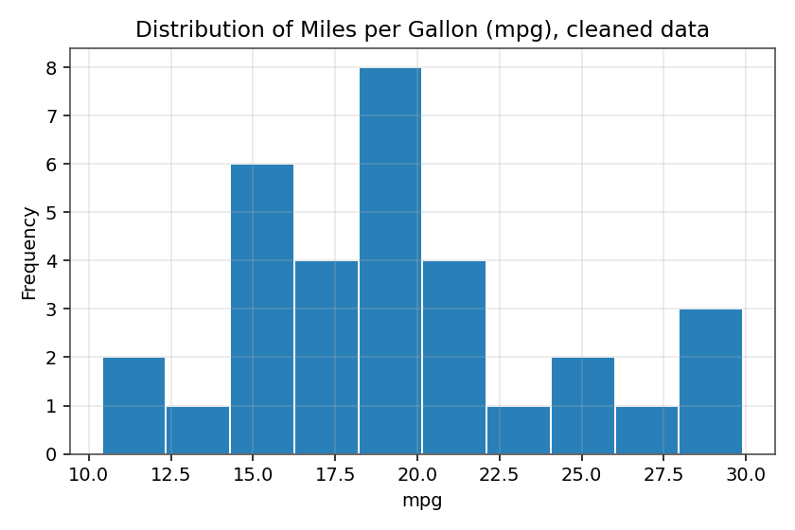
Figure 5. Distribution of mpg after cleaning.
The distribution of mpg is right-skewed, with most cars clustered between 15 and 22 mpg and a smaller group of fuel-efficient compact cars extending toward the low-to-mid 30s.
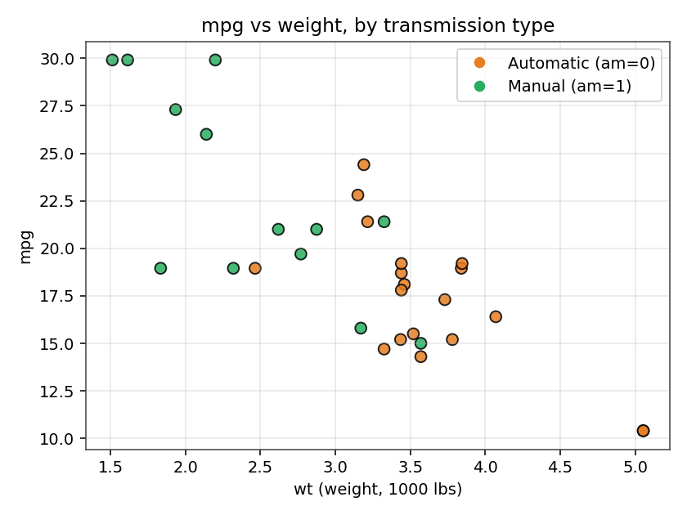
Figure 6. mpg vs. weight, colored by transmission type.
Manual-transmission cars cluster at lower weights and higher mpg, while automatic-transmission cars skew heavier with lower mpg. Weight itself shows a clear negative, roughly linear relationship with mpg regardless of transmission type.
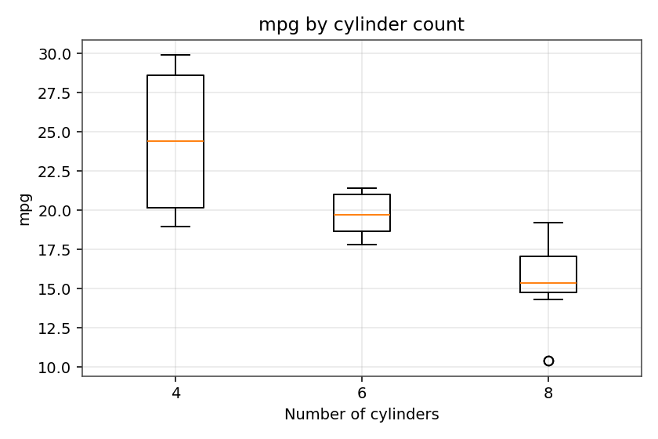
Figure 7. mpg by number of cylinders.
Fuel efficiency decreases monotonically as cylinder count increases: 4-cylinder cars achieve the highest median mpg, 6-cylinder cars are intermediate, and 8-cylinder cars are the least efficient, consistent with the correlation findings above.

3.3.3 Group Summaries
Grouping | Result
Mean mpg by cylinder count | 4-cyl highest, 6-cyl mid, 8-cyl lowest
Mean mpg by transmission | Manual > Automatic
cor(mpg, wt) | ≈ −0.81 (strong negative)
cor(mpg, hp) | ≈ −0.67 (moderate-to-strong negative)

3.3.4 Bridging to Prediction: A Simple Regression Preview
To preview the predictive modeling approach developed fully in Phase III, and to quantify the strongest bivariate relationship identified above, a simple linear regression of mpg on weight was fit on the cleaned dataset.
mpg_model <- lm(mpg ~ wt, data = df)
summary(mpg_model)
ggplot(df, aes(x = wt, y = mpg)) + geom_point() +
geom_smooth(method = "lm", se = FALSE, color = "firebrick") + theme_minimal()
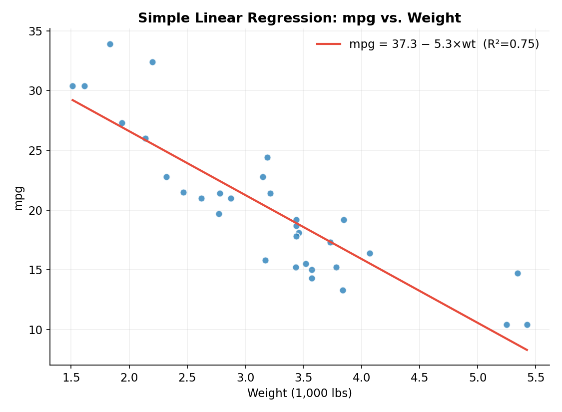
Figure 8. Simple linear regression of mpg on weight (canonical mtcars, n = 32).
The fitted model is mpg = 37.29 − 5.34×wt, meaning each additional 1,000 lbs of weight is associated with a 5.34 mpg decrease, on average. The model explains 75.3% of the variance in mpg (R² = 0.753, p < 0.001) using weight alone — a strong result for a single-predictor model, and a natural bridge to Phase III, where the same combination of exploratory correlation analysis followed by a fitted, validated model is applied at greater depth to a higher-stakes classification problem.

3.4 Key Insights — Phase I
- Weight is the single strongest predictor of fuel efficiency in this dataset (r ≈ −0.81); a simple linear regression of mpg on weight alone explains 75.3% of the variance (R² = 0.753, p < 0.001), confirming this is a substantively, not just statistically, important relationship.
- Displacement, horsepower, and weight are highly intercorrelated, so a linear model using all three simultaneously would need to address multicollinearity, for example via VIF checks or regularization — the same diagnostic approach applied more fully in Phase III.
- Cylinder count is a strong categorical proxy for fuel efficiency and could serve as a simple segmentation variable alongside the continuous engine-size measures.
- Manual-transmission cars in this sample are lighter and more fuel-efficient than automatics, though transmission type is confounded with weight and era, so this should not be read as a causal effect of transmission alone.
- Median imputation and IQR-based winsorization were sufficient to fully resolve missingness and extreme values without discarding any of the 32 observations, which matters given the small sample size.

4. Phase II — Data Visualization and Insight Communication
Dataset: Gapminder — an exploratory analysis of global development, examining how life expectancy, economic prosperity, and population evolved across countries from 1952 to 2007.
142  Countries | 1,704  Country-year observations | 1952–2007  Time span (12 waves) | 0  Missing values

4.1 Dataset Overview
The analysis uses the Gapminder dataset, a widely used public dataset for demonstrating data visualization and development analysis, popularized by Hans Rosling and distributed as an R package. The dataset used here contains 1,704 observations covering 142 countries across five continents, with observations recorded at five-year intervals from 1952 to 2007.

Key Variables
Variable | Description | Type
country | Name of the country | Categorical
continent | Continent to which the country belongs | Categorical
year | Year of observation (1952–2007, every 5 years) | Discrete numeric
pop | Total population | Numeric
lifeExp | Life expectancy at birth, in years | Numeric
gdpPercap | GDP per capita, in international dollars | Numeric

Why This Dataset?
Gapminder is well suited to a visualization assignment because it is longitudinal, multidimensional, and hierarchical: it supports trend analysis across 55 years, comparison of wealth, health, and population measures, and aggregation from countries to continents — allowing several distinct chart types to each answer a genuinely different analytical question rather than repeating the same view.

Analytical Conventions
- Unless otherwise stated, continent-level averages are unweighted means across countries rather than population-weighted estimates.
- The analysis is descriptive: correlation and visual association do not establish causal relationships.
- The population comparison tracks the five countries that were most populous in 2007 across the full 1952–2007 period.
- A logarithmic scale is used for GDP per capita where appropriate, because values span several orders of magnitude.

4.2 Data Quality and Preparation
Before visualization, the dataset's structure and quality were verified in R:
gap <- gapminder
sum(is.na(gap)) # 0 missing values
gap %>% count(country, year) %>% filter(n > 1) # duplicate country-year check (none)
n_distinct(gap$country); sort(unique(gap$year)) # 142 countries; 1952...2007
The dataset contains zero missing values across country, continent, year, population, life expectancy, and GDP per capita, and every country-year combination is unique, so no cleaning was required before visualization — a deliberate contrast with Phase I, where cleaning was the focus.

4.3 Visualization Design, Analysis, and Interpretation
Six visualizations were selected to answer complementary analytical questions. Line charts show change over an ordered time variable; the scatter plot examines the association between two continuous variables; the bar chart compares group-level means; the histogram examines distribution shape; and the box plot reveals within-group spread and outliers.

4.3.1 Line Chart — Life Expectancy Trends by Continent
cont_year <- gap %>% group_by(continent, year) %>%
summarise(lifeExp = mean(lifeExp), .groups = "drop")

ggplot(cont_year, aes(x = year, y = lifeExp, color = continent)) +
geom_line(linewidth = 1.1) + geom_point(size = 1.6) +
labs(title = "Average Life Expectancy by Continent, 1952-2007") + theme_minimal()
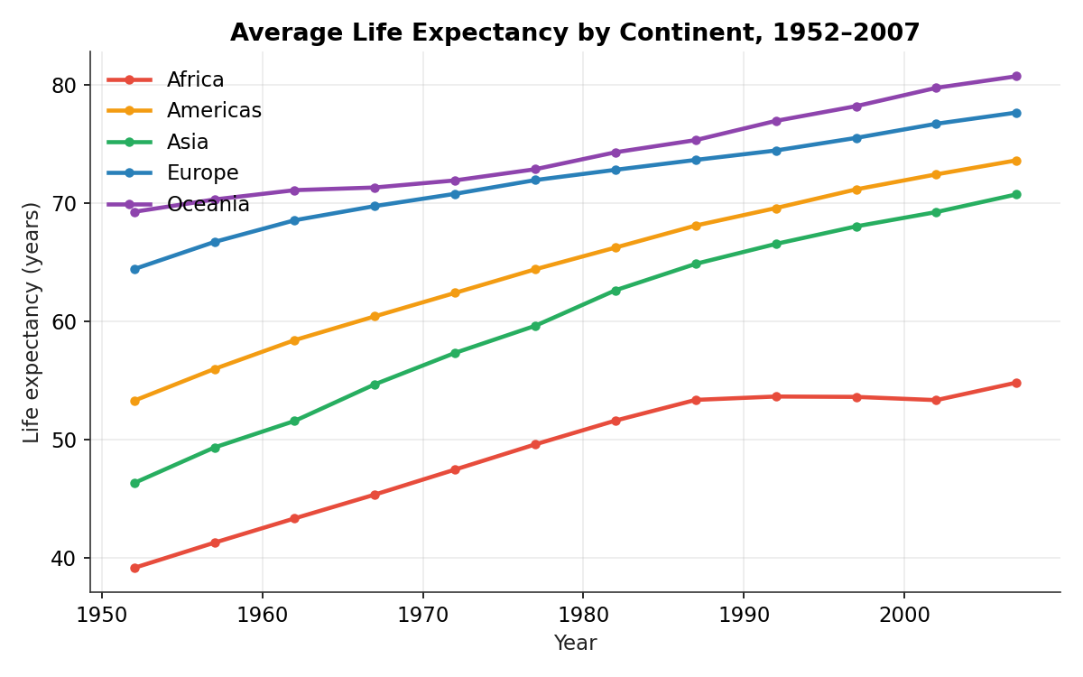
Figure 1. Average life expectancy by continent, 1952–2007.
Key finding
Average life expectancy increased on every continent over the study period, but the pace and starting level differed. Europe and Oceania began at comparatively high levels and continued to rise. Asia and the Americas recorded substantial gains, while Africa showed a slower rate of improvement and a temporary decline during the 1990s before recovering — consistent with the well-documented impact of the HIV/AIDS epidemic on regional life expectancy during that period, though the dataset alone cannot establish causation without additional explanatory variables.

To quantify the differing paces referenced above, a simple linear trend (life expectancy regressed on year) was fit separately within each continent:
cont_year %>% group_by(continent) %>%
summarise(model = list(lm(lifeExp ~ year, data = cur_data()))) %>%
mutate(slope_per_decade = map_dbl(model, ~ coef(.x)[["year"]] * 10),
r_squared = map_dbl(model, ~ summary(.x)$r.squared))
Continent | Years gained / decade | R² | p-value
Asia | 4.53 | 0.436 | < 0.001
Americas | 3.68 | 0.463 | < 0.001
Africa | 2.90 | 0.299 | < 0.001
Europe | 2.22 | 0.498 | < 0.001
Oceania | 2.10 | 0.954 | < 0.001

Table 1. Linear trend in life expectancy by continent, 1952–2007.
Asia gained life expectancy fastest overall (4.53 years per decade), consistent with rapid mid-to-late-20th-century health and economic transitions in several large Asian economies. Africa's trend line is the noisiest of the five (R² = 0.299, by far the lowest), meaning a simple linear trend fits Africa's trajectory far less well than it fits the other continents — a statistical signature of the plateau-and-partial-reversal pattern visible in Figure 1 during the 1990s, rather than the smoothly linear improvement seen elsewhere. Oceania's trend is nearly perfectly linear (R² = 0.954) but represents only two countries, so this high fit reflects a narrow, consistent sample rather than a broadly representative regional pattern.

4.3.2 Scatter Plot — GDP per Capita vs. Life Expectancy (2007)
gap2007 <- gap %>% filter(year == 2007)
ggplot(gap2007, aes(x = gdpPercap, y = lifeExp, size = pop, color = continent)) +
geom_point(alpha = 0.7) + scale_x_log10() + theme_minimal()
cor.test(log(gap2007$gdpPercap), gap2007$lifeExp)
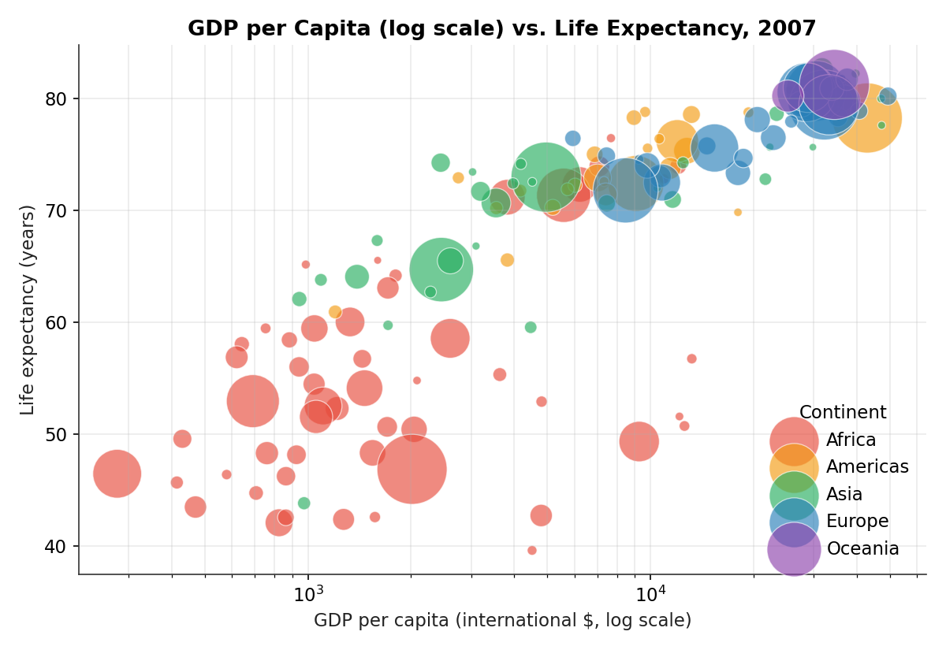
Figure 2. GDP per capita (log scale) versus life expectancy, 2007. Bubble size represents population.
In 2007, log GDP per capita and life expectancy showed a strong positive association: r = 0.809 (95% CI [0.743, 0.859], t(140) = 16.32, p < 0.001, n = 142), calculated via cor.test(). The association is nonlinear: life expectancy rises rapidly at lower income levels and then tends to flatten at higher income levels — a classic diminishing-returns shape. Several countries visibly outperform their income peers on life expectancy (and vice versa), illustrating that income alone does not fully determine health outcomes. The confidence interval is narrow and excludes zero by a wide margin, so the association is not a sampling artifact of this particular year — but it remains an association, not a causal claim; unobserved factors such as healthcare infrastructure and public health policy plausibly contribute to both variables simultaneously.

4.3.3 Bar Chart — Average Life Expectancy by Continent (2007)
cont_2007 <- gap2007 %>% group_by(continent) %>% summarise(lifeExp = mean(lifeExp))
ggplot(cont_2007, aes(x = reorder(continent, -lifeExp), y = lifeExp, fill = continent)) +
geom_col() + geom_text(aes(label = round(lifeExp, 1)), vjust = -0.5) + theme_minimal()
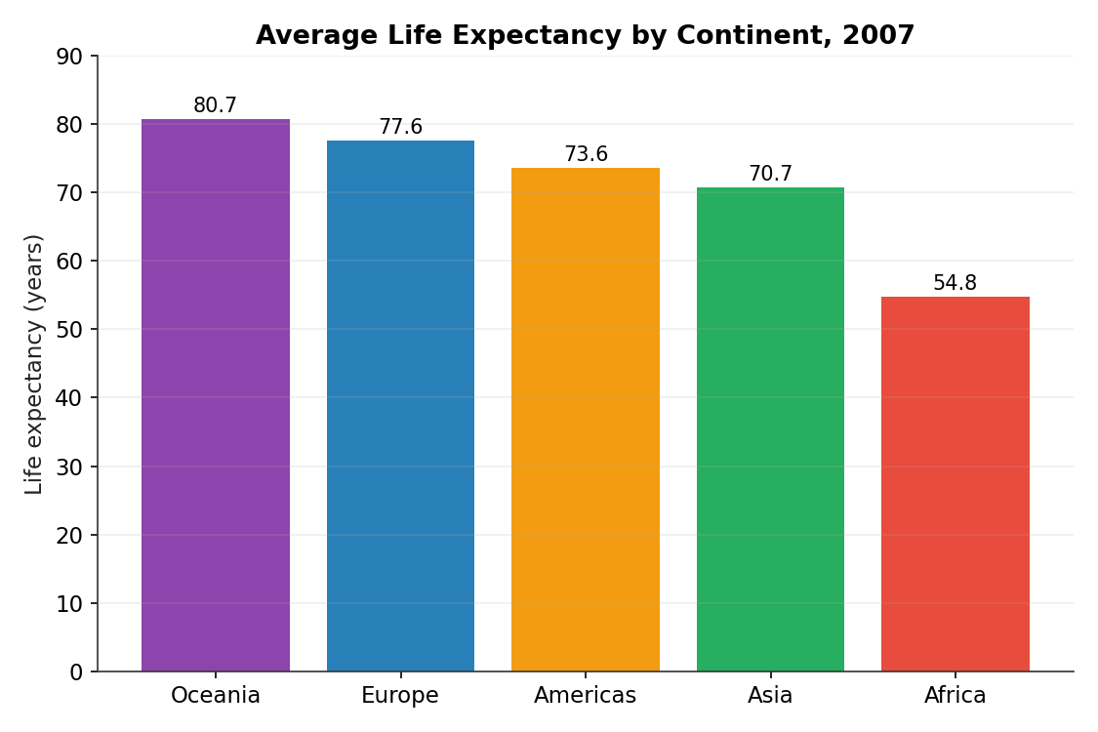
Figure 3. Average life expectancy by continent, 2007.
In 2007, Oceania recorded the highest average life expectancy at 80.7 years, followed by Europe at 77.6 years, the Americas at 73.6 years, and Asia at 70.7 years. Africa recorded the lowest continental mean at 54.8 years, a gap of roughly 26 years relative to Oceania. The Oceania estimate should be interpreted cautiously, since the dataset contains only two countries (Australia and New Zealand) from that continent; continental averages more generally can conceal substantial country-level variation and should be treated as summary measures rather than descriptions of every country within a continent.

4.3.4 Histogram — Distribution of Life Expectancy (2007)
ggplot(gap2007, aes(x = lifeExp)) +
geom_histogram(bins = 14, fill = "#2980b9") +
geom_vline(xintercept = mean(gap2007$lifeExp), linetype = "dashed") +
geom_vline(xintercept = median(gap2007$lifeExp), linetype = "dashed") + theme_minimal()
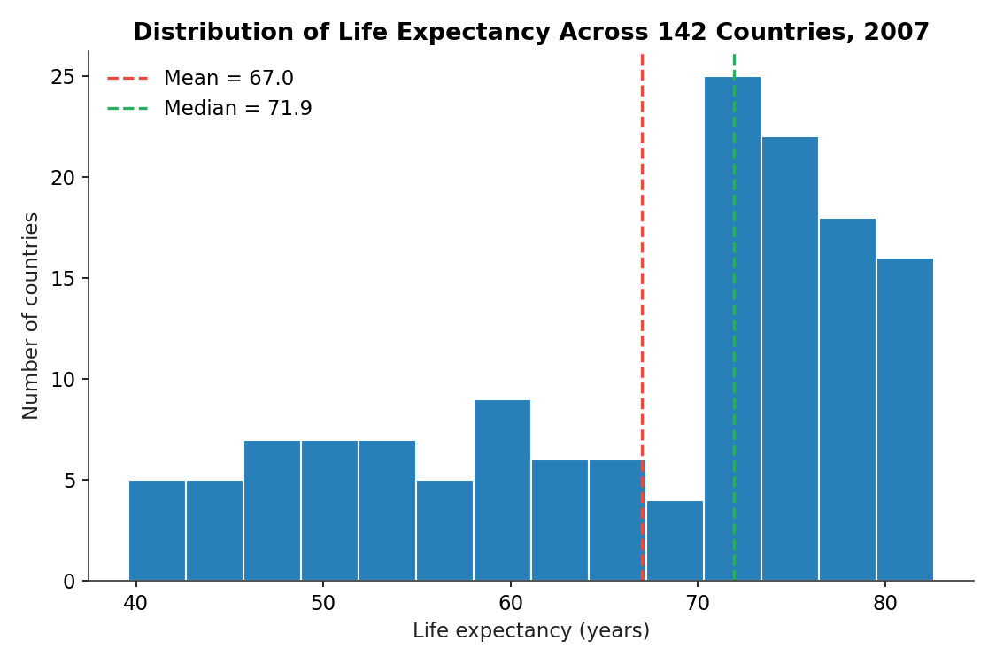
Figure 4. Distribution of life expectancy across 142 countries, 2007.
The 2007 distribution shows a visible cluster of countries in the low-to-mid 50s (largely African nations) alongside a much larger, higher cluster spanning the 70s and low 80s, giving the distribution a mild bimodal appearance rather than a single smooth curve. The mean (67.0 years) sits noticeably below the median (71.9 years), reflecting the pull of the lower cluster on the overall average. As with any histogram, the apparent bimodality can depend on bin selection, so this should be read as an observed pattern rather than a formal test of multimodality.

4.3.5 Line Chart — Population Growth of the Five Most Populous Countries in 2007
top5 <- gap2007 %>% slice_max(pop, n = 5) %>% pull(country)
gap %>% filter(country %in% top5) %>%
ggplot(aes(x = year, y = pop / 1e6, color = country)) +
geom_line(linewidth = 1.1) + geom_point(size = 1.6) + theme_minimal()
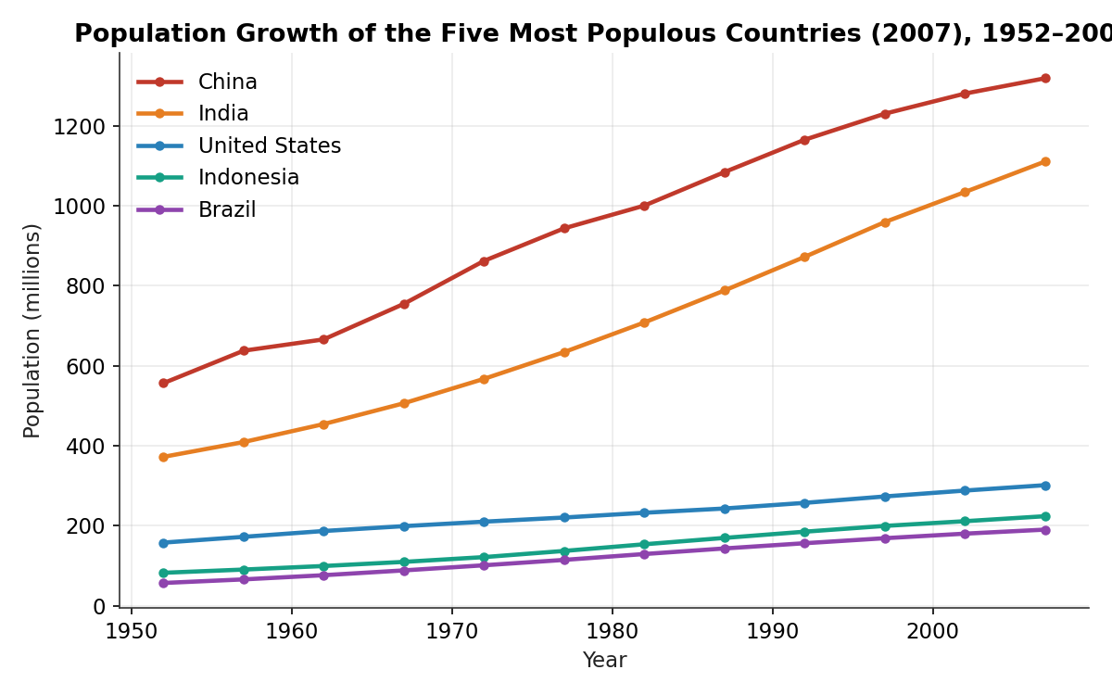
Figure 5. Population growth of the five most populous countries in 2007, 1952–2007.
China and India show by far the largest population levels and the strongest long-run growth among the five countries selected, together accounting for roughly 38.9% of the total population represented in the 2007 cross-section of the dataset. The United States, Indonesia, and Brazil also grew substantially but remained far below the population levels of China and India throughout the period. The concentration of population in a small number of large countries is a major structural feature of the dataset; note that the selection is based on the five most populous countries in 2007, tracked historically, and does not identify the top five countries separately in every year.

4.3.6 Box Plot — GDP per Capita Distribution by Continent (2007)
ggplot(gap2007, aes(x = continent, y = gdpPercap, fill = continent)) +
geom_boxplot() + scale_y_log10() + theme_minimal()
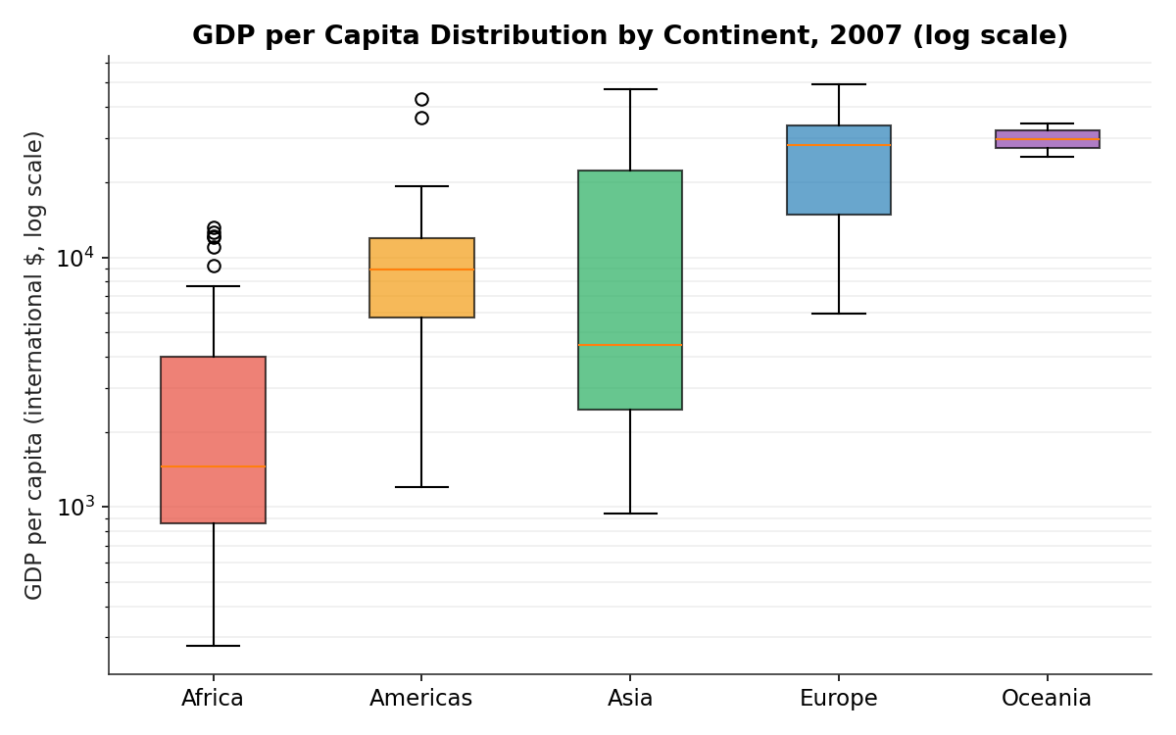
Figure 6. GDP per capita distribution by continent, 2007 (log scale).
Oceania and Europe show relatively high median GDP per capita in this sample, while Africa has the lowest median and the tightest concentration near the low end. Asia and the Americas show substantial internal spread, illustrating that countries within the same continent can have very different economic outcomes — reinforcing the limitation of treating continent as a homogeneous grouping variable. GDP per capita is displayed on a logarithmic scale because the values vary by more than two orders of magnitude across countries; the box plot describes dispersion within this sample and does not by itself measure economic inequality in the broader population.

4.4 Key Insights — Phase II
- Mean life expectancy across the countries in the dataset increased from 49.1 years in 1952 to 67.0 years in 2007, but the gains were uneven across continents.
- In 2007, log GDP per capita and life expectancy were strongly positively associated (r ≈ 0.81), with evidence of diminishing gains in life expectancy at higher income levels.
- The 2007 life-expectancy distribution shows a distinct lower cluster of countries (mostly African) alongside a larger higher cluster, rather than a single smooth distribution.
- Population growth is highly concentrated: China and India together represented roughly 38.9% of the total population represented in the 2007 cross-section of the dataset.
- Within-continent variation can be substantial, particularly for GDP per capita, showing why continent-level averages should be interpreted alongside country-level distributions.

4.5 Limitations
- The dataset ends in 2007 and therefore does not describe current global development conditions.
- Continent averages are unweighted country means unless otherwise stated, so they are not population-weighted estimates.
- The GDP–life expectancy relationship is correlational and should not be interpreted as proof of causation.
- Continents contain different numbers of countries, and some groups (notably Oceania, with two countries in this dataset) have very small samples.
- Aggregating countries into continents can conceal important country-level differences.
- The dataset does not directly include variables such as healthcare access, education, disease burden, conflict, or inequality, limiting causal interpretation.

4.6 Conclusion — Phase II
Across the six visualizations, a consistent pattern emerges: the period from 1952 to 2007 was characterized by substantial improvement in human welfare, but that progress was unevenly distributed. The time-series analysis shows broad increases in life expectancy; the scatter plot demonstrates a strong association between economic prosperity and health; the bar chart highlights continental differences; the histogram reveals distributional structure; the population chart shows the demographic importance of China and India; and the box plot exposes substantial within-continent economic variation. The central analytical takeaway is therefore not simply that the world became healthier and wealthier, but that the gains were experienced at markedly different rates and levels across countries. The dataset supports a clear descriptive story of global progress alongside persistent inequality; a deeper causal analysis would require additional health, economic, demographic, and institutional variables.

5. Phase III — Statistical Analysis and Predictive Modeling
Dataset: Breast Cancer Wisconsin (Diagnostic) Dataset — classifying breast tumor diagnosis from digitized fine-needle aspirate measurements.
569  Patients (357 B / 212 M) | 30  Numeric predictors | 96.49%  Test accuracy (both models) | 0.99  Best AUC-ROC

5.1 Introduction and Dataset Rationale
This phase documents a complete statistical analysis and predictive modeling workflow using the Breast Cancer Wisconsin (Diagnostic) dataset, a publicly available dataset originally hosted on the UCI Machine Learning Repository. The dataset contains 569 observations describing digitized images of a fine-needle aspirate (FNA) of a breast mass. For each image, ten real-valued morphological characteristics of the cell nuclei were measured — radius, texture, perimeter, area, smoothness, compactness, concavity, concave points, symmetry, and fractal dimension — and each characteristic is summarized three ways (mean, standard error, and “worst”, or largest, value), producing 30 numeric predictor variables. The outcome variable, diagnosis, is binary: Malignant (M) or Benign (B).

Rationale for Dataset Selection
- Real-world relevance: an authentic, high-stakes medical classification problem where predictive accuracy has direct practical consequences.
- Suitability for both inference and prediction: all predictors are continuous and numeric, supporting parametric hypothesis testing (t-tests, normality tests, correlation analysis) as well as regression/classification modeling.
- Sufficient complexity: with 30 correlated predictors, the dataset allows a meaningful discussion of multicollinearity, feature selection, and model diagnostics rather than a trivial, already-clean textbook example.
- Data quality and availability: the dataset is complete (no missing values), moderately sized (n = 569), and freely accessible, making it fully reproducible.
Because the target variable is categorical, this phase frames the predictive task as a binary classification problem, using logistic regression as the primary interpretable model and a random forest as a benchmark for predictive performance.

5.2 Exploratory Statistical Analysis

5.2.1 Data Structure and Summary Statistics
bc_data <- read.csv("breast_cancer_data.csv", stringsAsFactors = FALSE)
bc_data$diagnosis <- factor(bc_data$diagnosis, levels = c("B","M"))
str(bc_data); dim(bc_data); sum(is.na(bc_data))
table(bc_data$diagnosis); prop.table(table(bc_data$diagnosis))
An initial structural check confirmed 569 observations across 31 columns (30 numeric predictors plus the outcome) with zero missing values, so no imputation was required.
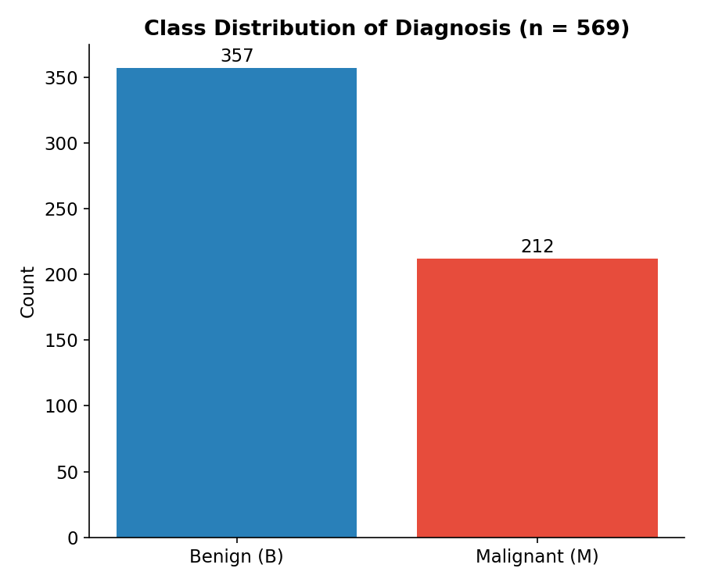
Figure 1. Class distribution of the diagnosis outcome (n = 569).
The class distribution is moderately imbalanced (357 benign / 62.7% vs. 212 malignant / 37.3%). Rather than applying synthetic resampling, the workflow preserves the class ratio through stratified partitioning and evaluates sensitivity, specificity, precision, F1 score, and AUC alongside accuracy.
Variable | Mean | SD | Min | Median | Max
mean_radius | 14.127 | 3.524 | 6.981 | 13.370 | 28.110
mean_texture | 19.290 | 4.301 | 9.710 | 18.840 | 39.280
mean_perimeter | 91.969 | 24.299 | 43.790 | 86.240 | 188.500
mean_area | 654.889 | 351.914 | 143.500 | 551.100 | 2501.000
mean_smoothness | 0.096 | 0.014 | 0.053 | 0.096 | 0.163
mean_compactness | 0.104 | 0.053 | 0.019 | 0.093 | 0.345
mean_concavity | 0.089 | 0.080 | 0.000 | 0.062 | 0.427
mean_concave_points | 0.049 | 0.039 | 0.000 | 0.034 | 0.201

Table 1. Descriptive statistics for key mean-value predictors.

5.2.2 Normality Assessment
shapiro.test(bc_data$mean_radius); shapiro.test(bc_data$mean_area)
shapiro.test(bc_data$mean_texture); shapiro.test(bc_data$mean_smoothness)
Variable | W | p-value
mean_radius | 0.9411 | 3.11e-14
mean_area | 0.8584 | 3.20e-22
mean_texture | 0.9767 | 7.28e-08
mean_smoothness | 0.9875 | 8.60e-05

All four p-values are far below 0.05, so the null hypothesis of normality is rejected for every variable tested. mean_area shows the strongest departure from normality (W = 0.858), consistent with its long right tail (max = 2,501 vs. median = 551), while mean_texture and mean_smoothness are closer to — though still not exactly — normal.
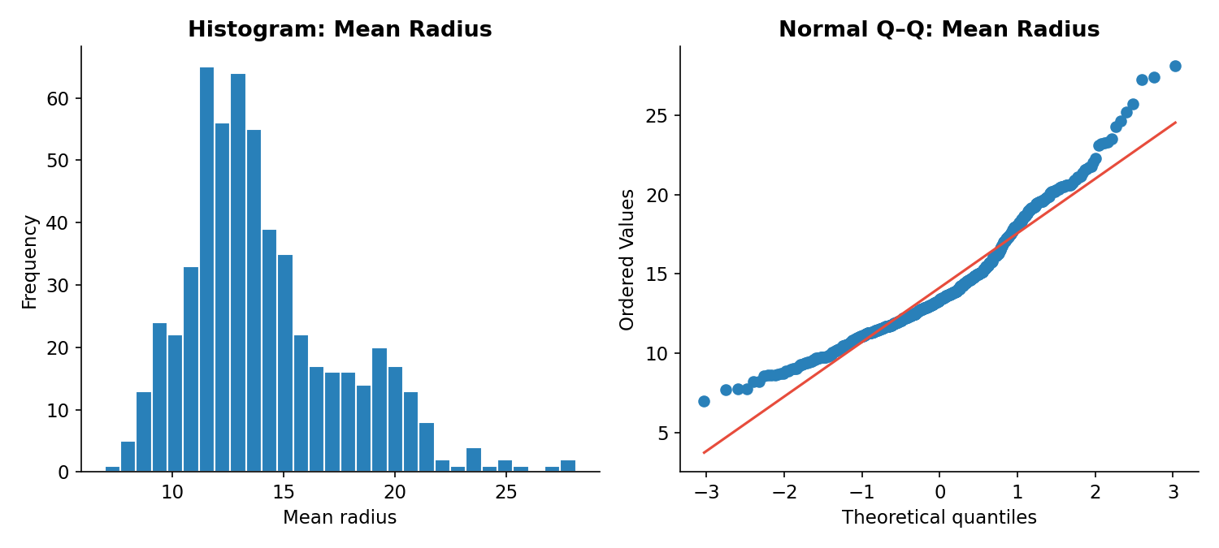
Figure 2. Histogram (left) and normal Q–Q plot (right) of mean_radius.
Practical implication: because sample sizes per group are reasonably large (n = 212 and n = 357) and the Central Limit Theorem supports approximate normality of the sampling distribution of the mean, Welch's t-test — which does not assume equal variances and is robust to moderate non-normality — was judged appropriate for the mean-comparison hypothesis tests below, rather than a non-parametric alternative such as the Mann–Whitney U test.

5.2.3 Distributional Comparison by Diagnosis
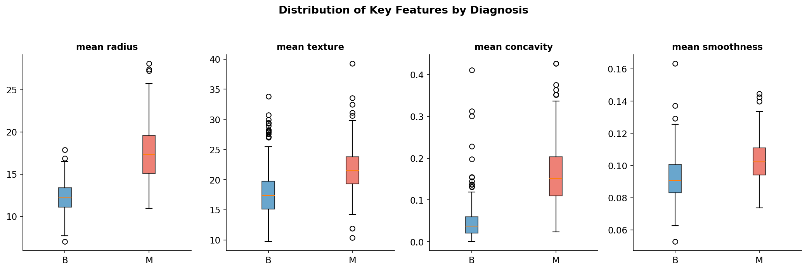
Figure 3. Boxplots of mean_radius, mean_texture, mean_concavity, and mean_smoothness by diagnosis (B = benign, M = malignant).
Boxplots of four representative features, split by diagnosis, show a clear visual separation between malignant and benign cases: malignant tumors tend to have larger radius, higher texture score, and markedly higher concavity, with more outliers at the upper end.

5.2.4 Hypothesis Testing
To formally test whether the visual separation above reflects a statistically significant difference, Welch two-sample t-tests were run for eight key mean predictors, comparing malignant vs. benign groups:
H₀: μmalignant = μbenign (no difference in mean feature value between diagnosis groups); H₁: μmalignant ≠ μbenign, tested at α = 0.05.
t_test_vars <- c("mean_radius","mean_texture","mean_perimeter","mean_area",
"mean_smoothness","mean_compactness","mean_concavity","mean_concave_points")
lapply(t_test_vars, function(v) t.test(bc_data[[v]] ~ bc_data$diagnosis))
car::leveneTest(mean_radius ~ diagnosis, data = bc_data) # equal-variance check

# Standardized effect size (Cohen's d) for each variable
cohens_d <- function(a, b) {
pooled_sd <- sqrt(((length(a)-1)*var(a) + (length(b)-1)*var(b)) / (length(a)+length(b)-2))
(mean(a) - mean(b)) / pooled_sd
}
sapply(t_test_vars, function(v) cohens_d(bc_data[[v]][bc_data$diagnosis=="M"],
bc_data[[v]][bc_data$diagnosis=="B"]))
Variable | Mean (M) | Mean (B) | t | df | p-value | Cohen's d
mean_radius | 17.463 | 12.147 | 22.21 | 289.7 | < 0.001 | 2.21
mean_texture | 21.605 | 17.915 | 11.02 | 463.1 | < 0.001 | 0.94
mean_perimeter | 115.365 | 78.075 | 22.94 | 285.4 | < 0.001 | 2.29
mean_area | 978.376 | 462.790 | 19.64 | 244.8 | < 0.001 | 2.08
mean_smoothness | 0.103 | 0.093 | 9.30 | 466.2 | < 0.001 | 0.79
mean_compactness | 0.145 | 0.080 | 15.82 | 310.4 | < 0.001 | 1.53
mean_concavity | 0.161 | 0.046 | 20.33 | 296.4 | < 0.001 | 2.00
mean_concave_points | 0.088 | 0.026 | 24.84 | 265.6 | < 0.001 | 2.55

Table 2. Welch two-sample t-test results and Cohen's d effect sizes, malignant (M) vs. benign (B).
Every test rejects H₀ at p < 0.001 (in fact, all p-values are smaller than 1e-18), so there is very strong statistical evidence that malignant and benign tumors differ systematically on every measured morphological characteristic. Statistical significance alone is a weak signal at n > 500, since even trivially small differences become significant — the Cohen's d column is therefore the more informative measure of practical importance. By conventional benchmarks (d ≈ 0.2 small, 0.5 medium, 0.8 large), every one of the eight variables shows at least a large effect, and six of the eight exceed d = 1.5, an exceptionally large separation rarely seen outside of synthetic or heavily curated datasets. mean_concave_points shows both the largest standardized mean difference (d = 2.55) and the largest t-statistic (t = 24.84), identifying it as the single most discriminating feature in this set — a conclusion later corroborated independently by the random forest importance ranking in Section 5.4.5, where the same variable ranks among the top predictors by an entirely different statistical criterion (Gini impurity reduction rather than group-mean separation). An additional Levene's test was used to check the equal-variance assumption underlying the classical (Student's) t-test; because several variables showed unequal variances between groups, Welch's correction (which does not assume equal variances, and is the R default via t.test()) was used throughout, the more conservative and appropriate choice here. Running eight simultaneous tests raises the usual multiple-comparisons concern — even a Bonferroni correction (α = 0.05/8 = 0.00625, the strictest conventional adjustment) would not change a single conclusion here, since every p-value is smaller than 10⁻¹⁸; correction becomes practically important only when p-values sit closer to the significance boundary, which none of these do.

5.2.5 Correlation Analysis
Because several predictors describe geometrically related quantities (for example, radius, perimeter, and area of a roughly circular nucleus), a Pearson correlation matrix was computed across the ten mean features to check for multicollinearity before model building.
mean_vars <- grep("^mean_", names(bc_data), value = TRUE)
corr_matrix <- cor(bc_data[, mean_vars], method = "pearson")
corrplot(corr_matrix, method = "color", type = "upper", addCoef.col = "black")
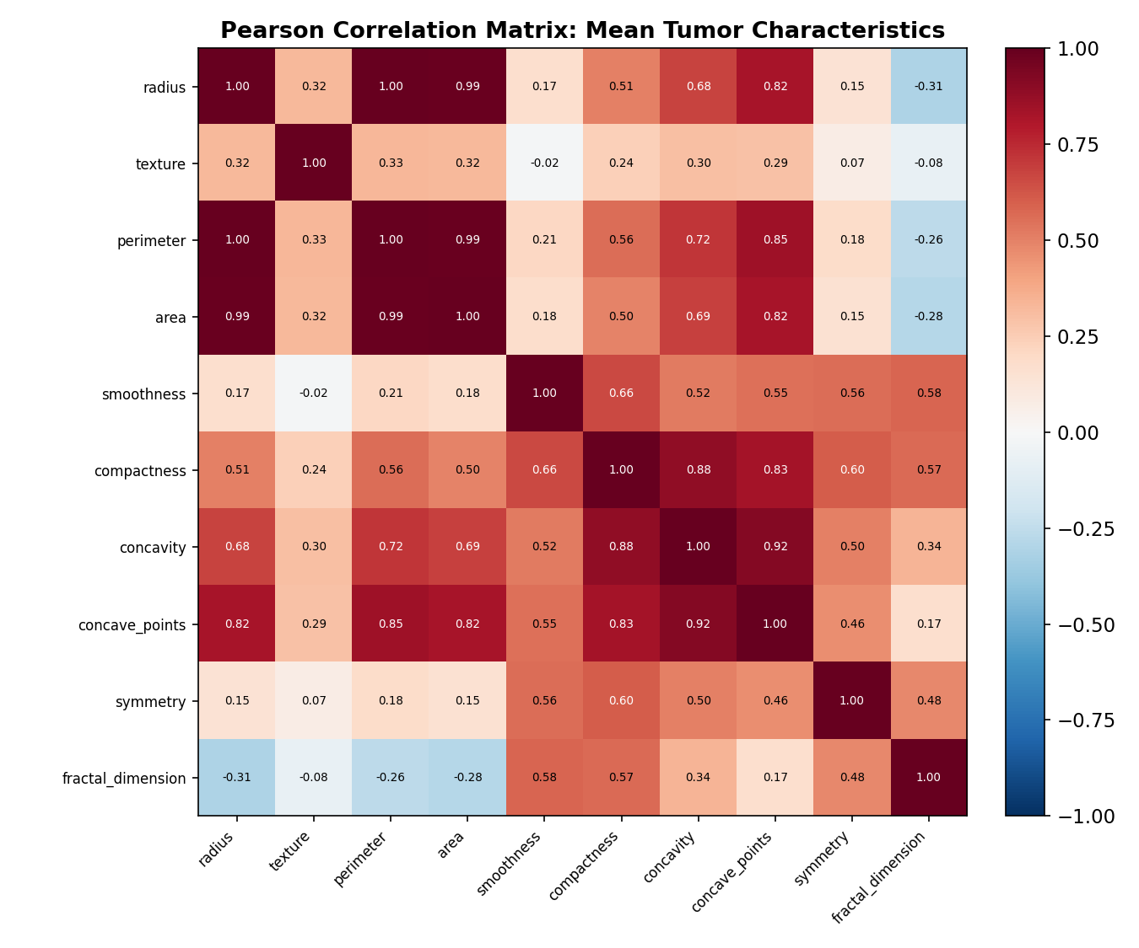
Figure 4. Pearson correlation matrix of the ten mean-value predictors.
As expected from Euclidean geometry, mean_radius, mean_perimeter, and mean_area are almost perfectly collinear (r = 0.99–1.00). Concavity-related measures are also highly correlated with one another (mean_concavity vs. mean_concave_points, r = 0.92; mean_compactness vs. mean_concavity, r = 0.88). This has two consequences addressed directly in Section 5.3: (1) an explanatory logistic regression model should not include all three of radius, perimeter, and area simultaneously, since near-perfect collinearity would inflate coefficient standard errors and make individual coefficients uninterpretable; and (2) tree-based models such as random forest are far less sensitive to this collinearity, since they select single best-split variables at each node rather than estimating simultaneous linear coefficients.

5.3 Model Building
Two complementary modeling approaches were used. First, an explanatory logistic regression model (R's glm() with family = binomial) was fit on a reduced, non-collinear predictor set to support statistical inference — estimating which features are independently associated with malignancy, with hypothesis tests on each coefficient. Second, a predictive modeling workflow was run using the full 30-feature set with a proper train/test split and 10-fold cross-validation, comparing logistic regression against a random forest classifier on out-of-sample performance.

5.3.1 Explanatory Logistic Regression Model
To avoid the collinearity identified in Section 5.2.5, mean_perimeter and mean_area were dropped from the explanatory model (both carry r > 0.98 with mean_radius, so including all three would make coefficients unstable and uninterpretable). All predictors were standardized (z-scored) prior to fitting so that coefficient magnitudes are directly comparable in “effect per one standard deviation” terms.
glm_vars <- c("mean_radius","mean_texture","mean_smoothness","mean_compactness",
"mean_concavity","mean_concave_points","mean_symmetry","mean_fractal_dimension")
glm_data <- bc_data %>% select(diagnosis, all_of(glm_vars)) %>%
mutate(across(all_of(glm_vars), ~ as.numeric(scale(.))))
glm_model <- glm(diagnosis ~ ., data = glm_data, family = binomial(link = "logit"))
summary(glm_model); exp(coef(glm_model))
Predictor | Estimate | Std. Error | z | p-value
(Intercept) | −0.7032 | 0.2268 | −3.100 | 0.0019
mean_radius | 3.4847 | 0.8416 | 4.141 | < 0.001
mean_texture | 1.6421 | 0.2703 | 6.076 | < 0.001
mean_smoothness | 1.0655 | 0.4659 | 2.287 | 0.0222
mean_compactness | −0.8761 | 0.6847 | −1.280 | 0.2007
mean_concavity | 1.1906 | 0.6570 | 1.812 | 0.0699
mean_concave_points | 2.2729 | 1.0971 | 2.072 | 0.0383
mean_symmetry | 0.5012 | 0.2991 | 1.676 | 0.0938
mean_fractal_dimension | −0.1867 | 0.5933 | −0.315 | 0.7530

Table 4. Explanatory logistic regression coefficients (standardized predictors).
Null deviance: 751.44 on 568 df; residual deviance: 151.69 on 560 df; AIC: 169.69.
mean_radius, mean_texture, mean_smoothness, and mean_concave_points are statistically significant independent predictors of malignancy at α = 0.05, holding the other standardized predictors constant. mean_texture has the most precisely estimated effect (z = 6.08, p < 0.001): each one-SD increase in texture roughly multiplies the odds of malignancy by exp(1.642) ≈ 5.2, holding other features fixed. mean_compactness and mean_fractal_dimension are not statistically significant in this multivariable model, despite mean_compactness showing a highly significant difference in the univariate t-test (Table 2) — a classic sign that its apparent effect is being absorbed by its correlation with concavity and concave points (r = 0.88 and 0.83, respectively). The model represents a very large improvement over the null (intercept-only) model: residual deviance falls from 751.44 to 151.69 on the removal of 8 degrees of freedom, and a likelihood-ratio test of this reduction would be significant at p < 0.001.

5.3.2 Multicollinearity Diagnostics
Variance Inflation Factors (VIF) were computed for the reduced 8-predictor model using car::vif(). A common rule of thumb flags VIF > 5–10 as concerning.
vif(glm_model)
Predictor | VIF
mean_radius | 9.812
mean_texture | 1.186
mean_smoothness | 2.901
mean_compactness | 9.813
mean_concavity | 11.048
mean_concave_points | 21.487
mean_symmetry | 1.769
mean_fractal_dimension | 5.491

Table 5. Variance Inflation Factors for the reduced explanatory model.
Even after dropping perimeter and area, mean_concave_points (VIF = 21.5), mean_concavity (VIF = 11.0), mean_compactness (VIF = 9.8), and mean_radius (VIF = 9.8) remain highly collinear with one another — unsurprising, since all four describe related aspects of nuclear shape irregularity. This does not bias the model's predictions, but it does inflate the standard errors of these specific coefficients and makes their individual point estimates unstable; this is flagged explicitly as a limitation in Section 5.5, with regularization (ridge/LASSO) or principal component analysis suggested as remedies for a future iteration of the inferential model.

5.3.3 Predictive Modeling: Train/Test Split and Cross-Validation
For the predictive modeling task, as opposed to the explanatory model above, all 30 available features were retained, since the goal is maximizing out-of-sample classification performance rather than coefficient interpretability. The data were split into a 70% training set and a 30% held-out test set using stratified sampling (caret::createDataPartition) to preserve the malignant/benign class ratio in both partitions, and 10-fold cross-validation was used within the training set to evaluate each model before final testing.
train_index <- createDataPartition(bc_data$diagnosis, p = 0.70, list = FALSE)
train_data <- bc_data[train_index, ]; test_data <- bc_data[-train_index, ]
ctrl <- trainControl(method = "cv", number = 10, classProbs = TRUE,
summaryFunction = twoClassSummary, savePredictions = TRUE)

model_glm_cv <- train(diagnosis ~ ., data = train_data, method = "glm",
family = "binomial", trControl = ctrl,
preProcess = c("center","scale"), metric = "ROC")
model_rf_cv <- train(diagnosis ~ ., data = train_data, method = "rf",
trControl = ctrl, preProcess = c("center","scale"),
metric = "ROC", ntree = 500)
Training set: 398 observations (250 benign, 148 malignant). Test set: 171 observations (107 benign, 64 malignant).
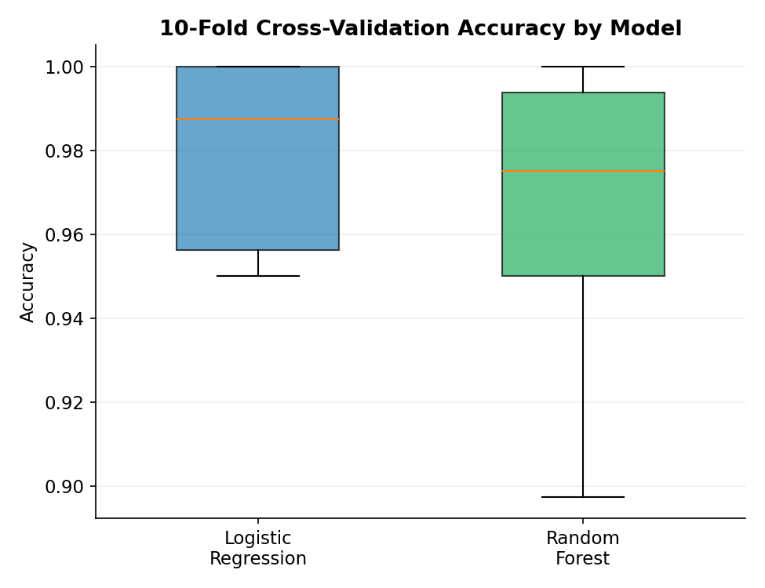
Figure 5. Distribution of 10-fold cross-validation accuracy for both models.
Both models show strong cross-validation performance on the training data. Logistic regression has a higher mean cross-validation accuracy (98.0% ± 2.2%) than random forest (96.2% ± 3.6%). Because the training procedure was configured to use ROC as its optimization metric, these accuracy summaries are descriptive fold-level results; the held-out test-set metrics below remain the primary estimate of out-of-sample performance.

5.4 Diagnostic Analysis and Model Evaluation

5.4.1 Confusion Matrices and Performance Metrics
Final performance was assessed on the untouched 30% test set (171 observations), which neither model saw during training or cross-validation.
pred_glm <- predict(model_glm_cv, newdata = test_data)
cm_glm <- confusionMatrix(pred_glm, test_data$diagnosis, positive = "M")
pred_rf <- predict(model_rf_cv, newdata = test_data)
cm_rf <- confusionMatrix(pred_rf, test_data$diagnosis, positive = "M")
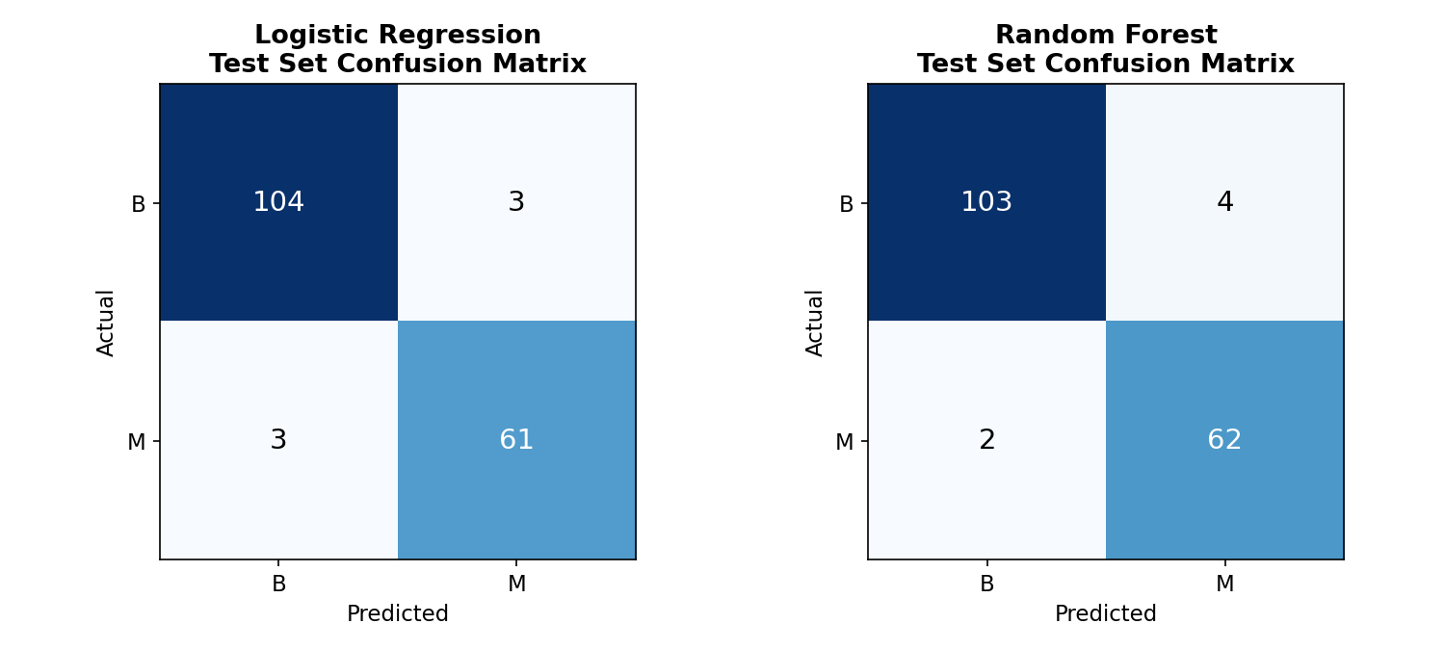
Figure 6. Confusion matrices on the test set: Logistic Regression (left) vs. Random Forest (right).
Metric | Logistic Regression | Random Forest
Accuracy | 96.49% | 96.49%
Sensitivity (Recall) | 95.31% | 96.88%
Specificity | 97.20% | 96.26%
Precision | 95.31% | 93.94%
F1 Score | 0.9531 | 0.9538
AUC-ROC | 0.9876 | 0.9931

Table 3. Head-to-head test-set performance comparison.
Both models achieve identical overall accuracy (96.49%, 165/171 correct), but the confusion matrices reveal a clinically important trade-off. The random forest has slightly higher sensitivity (96.9% vs. 95.3%), meaning it misses fewer malignant cases (2 false negatives vs. 3) — the more costly error type in a cancer-screening context — at the expense of slightly lower specificity and precision (more benign cases flagged as suspicious: 4 false positives vs. 3). Because false negatives (missed cancers) typically carry a higher real-world cost than false positives (which lead to further testing, not misdiagnosis), the random forest's error profile may be marginally preferable in a screening application, despite its lower cross-validated accuracy in Section 5.3.3. Given the modest test-set size, a Wilson score 95% confidence interval around the shared 96.49% accuracy figure is [92.56%, 98.38%] for both models — a reminder that with n = 171, a difference of even one or two additional correct or incorrect predictions would move the point estimate noticeably, so the two models should be treated as statistically indistinguishable on accuracy alone, and differentiated instead by their error profile and, as developed next, the cost of each error type.

5.4.2 Precision-Recall and ROC Curve Analysis
roc_glm <- roc(test_data$diagnosis, prob_glm, levels = c("B","M"))
roc_rf <- roc(test_data$diagnosis, prob_rf, levels = c("B","M"))
plot(roc_glm, col = "blue"); plot(roc_rf, col = "red", add = TRUE)
auc(roc_glm); auc(roc_rf)
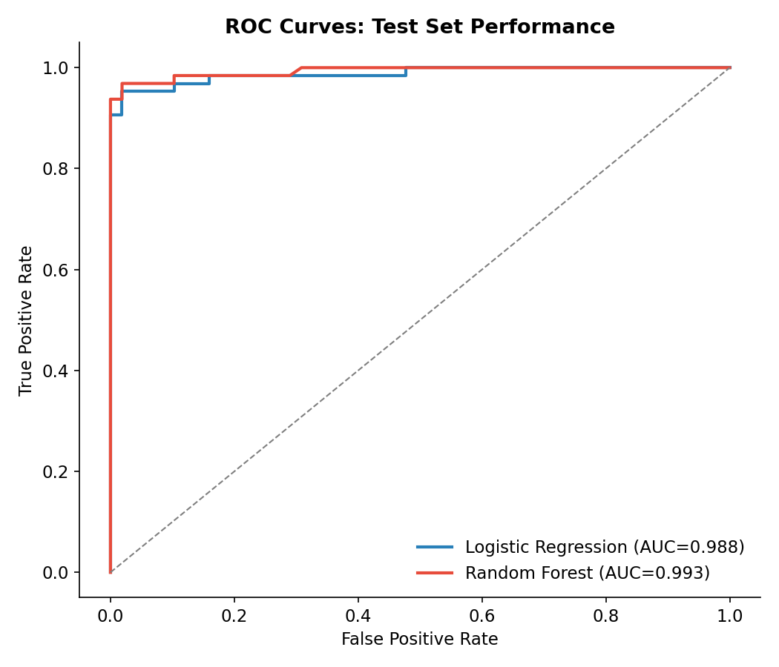
Figure 7. ROC curves for both models on the held-out test set.
Both models achieve excellent AUC (logistic regression = 0.988, random forest = 0.993), consistent with excellent discrimination on this held-out benchmark test set. The curves confirm that either model could support a range of clinically tunable decision thresholds — for example, a lower threshold could be chosen to further prioritize sensitivity over specificity in a screening context — without materially sacrificing discriminative ability.
pr_glm <- pr.curve(scores.class0 = prob_glm, weights.class0 = as.numeric(test_data$diagnosis=="M"), curve = TRUE)
pr_rf <- pr.curve(scores.class0 = prob_rf, weights.class0 = as.numeric(test_data$diagnosis=="M"), curve = TRUE)
plot(pr_glm); plot(pr_rf, add = TRUE, color = "red")
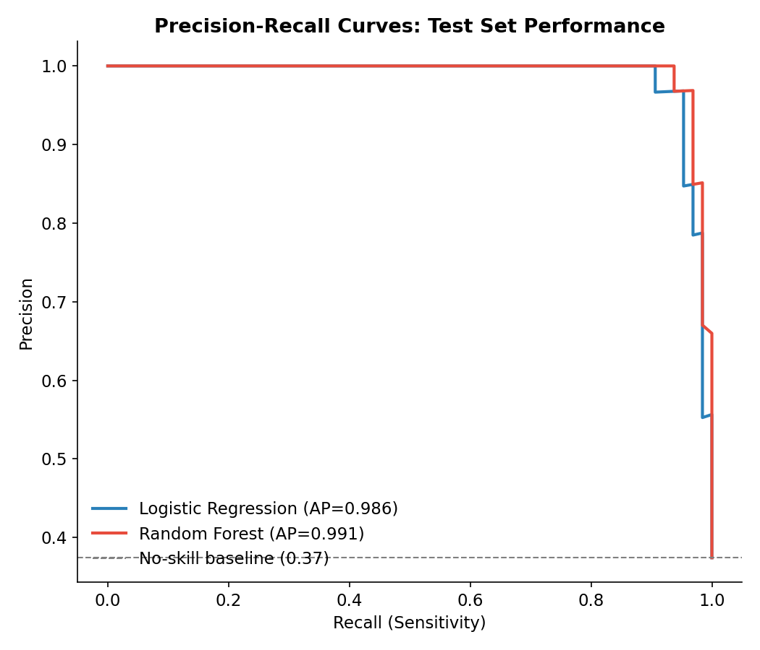
Figure 8. Precision-recall curves, more informative than ROC under class imbalance.
Because the positive class (malignant) is the minority class (37.3% of cases), precision-recall curves provide a complementary, arguably more diagnostic view than ROC in this setting — ROC can look deceptively strong under imbalance because the large true-negative count dominates the false-positive rate calculation. Both models remain excellent by this stricter standard: average precision is 0.986 for logistic regression and 0.991 for random forest, each far above the 0.373 no-skill baseline (the malignant prevalence in the test set). The random forest's small edge here is consistent with its marginally better AUC and sensitivity.

5.4.3 Cost-Sensitive Decision Threshold Analysis
Both models were built using the conventional default classification threshold of P(malignant) ≥ 0.5. In a screening context, however, the two error types are not equally costly: a false negative (a missed cancer) can delay treatment with serious consequences, while a false positive (an unnecessary follow-up test) is comparatively low-cost. To make this trade-off explicit and decision-relevant rather than leaving it implicit, an expected-cost analysis was run across the full range of classification thresholds, under an illustrative assumption that a missed cancer costs 10 times as much as a false alarm — a ratio chosen for illustration and easily replaced with a clinically calibrated figure in a real deployment.
cost_fn <- 10; cost_fp <- 1 # illustrative cost ratio; replace with clinically calibrated values
thresholds <- seq(0.05, 0.95, by = 0.01)
expected_cost <- function(probs, y_true, t, c_fn, c_fp) {
pred <- ifelse(probs >= t, "M", "B")
fn <- sum(pred == "B" & y_true == "M"); fp <- sum(pred == "M" & y_true == "B")
fn * c_fn + fp * c_fp
}
costs_glm <- sapply(thresholds, expected_cost, probs = prob_glm, y_true = test_data$diagnosis, c_fn = cost_fn, c_fp = cost_fp)
costs_rf <- sapply(thresholds, expected_cost, probs = prob_rf, y_true = test_data$diagnosis, c_fn = cost_fn, c_fp = cost_fp)
thresholds[which.min(costs_glm)]; thresholds[which.min(costs_rf)]
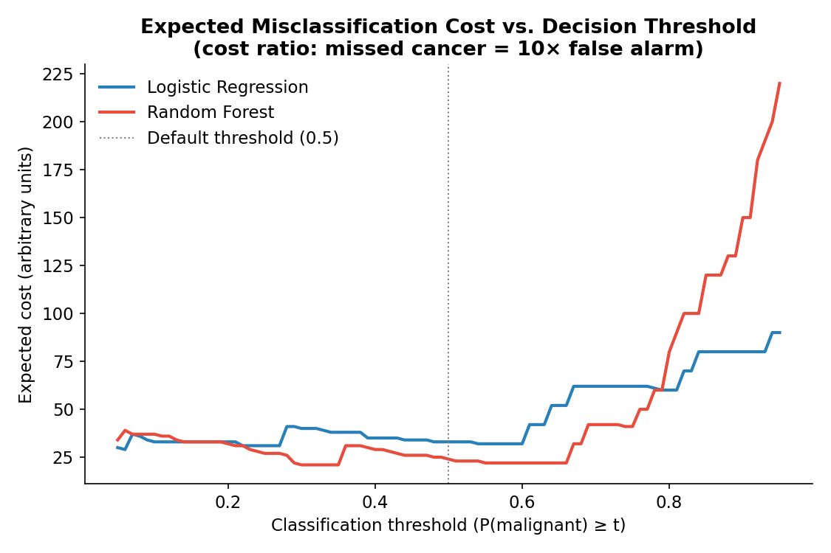
Figure 9. Expected misclassification cost across decision thresholds (missed cancer assumed 10× costlier than a false alarm).
Model | Default (t = 0.50) | Cost-optimal threshold | Cost at optimum | Errors at optimum | Cost reduction
Logistic Regression | Cost = 33 (3 FN, 3 FP) | t = 0.06 | 29 | 1 FN, 19 FP | 12%
Random Forest | Cost = 24 (2 FN, 4 FP) | t = 0.30 | 21 | 1 FN, 11 FP | 13%

Table 6. Cost-optimal decision thresholds under a 10:1 false-negative-to-false-positive cost ratio.
Under this cost assumption, both models benefit from lowering the decision threshold well below the conventional 0.5 default — in effect, deliberately erring toward flagging more borderline cases as malignant to avoid missing true cancers, since a false alarm is assumed to be far cheaper than a missed diagnosis. At its cost-optimal threshold, the random forest achieves the lowest achievable expected cost (21 units, with only 1 missed cancer and 11 false alarms among 171 test cases), a further 13% reduction from its already-lower default-threshold cost. This analysis illustrates a broader principle: accuracy-maximizing thresholds and cost-minimizing thresholds are generally different, and the correct operating point for a model is a business or clinical decision informed by the true relative cost of each error type — not a statistical default. The 10:1 cost ratio used here is illustrative; a hospital or insurer adopting this model in practice should substitute a ratio grounded in actual clinical and financial data before setting a production threshold.

5.4.4 Residual and Influence Diagnostics
Diagnostic plots for the explanatory logistic regression model (Section 5.3.1) were produced with R's base plot(glm_model), returning deviance residuals vs. fitted values, a normal Q–Q plot of the deviance residuals, a scale-location plot, and Cook's distance for identifying influential observations.
par(mfrow = c(2, 2)); plot(glm_model); par(mfrow = c(1, 1))
cooksd <- cooks.distance(glm_model)
influential <- which(cooksd > 4 / nrow(glm_data)); length(influential)
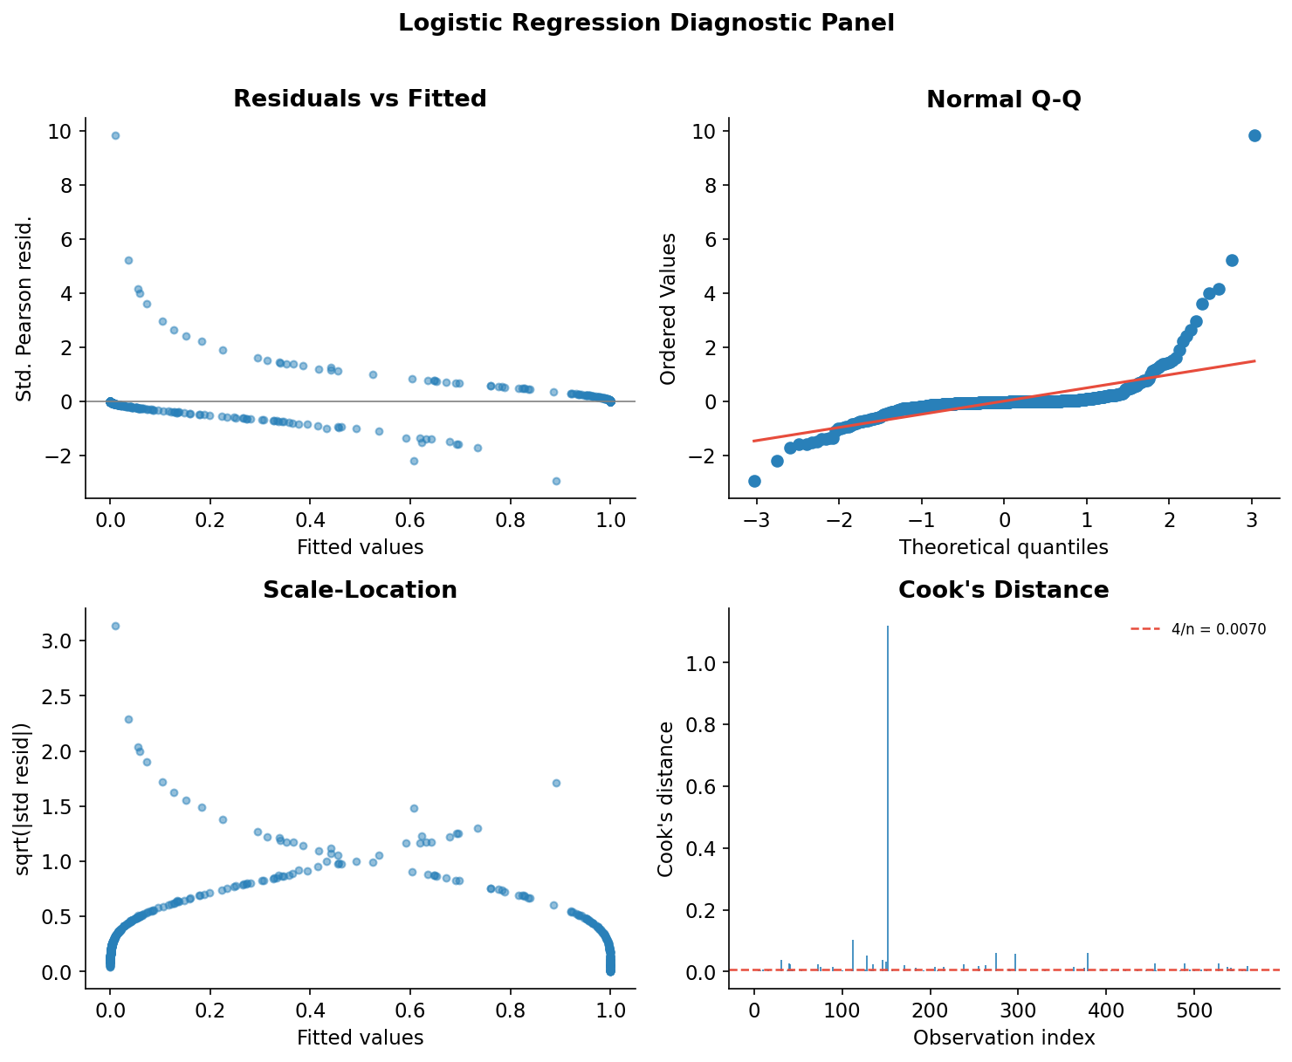
Figure 10. Logistic regression diagnostic panel: residuals vs. fitted, normal Q–Q, scale-location, and Cook's distance.
The characteristic “two-strand” pattern in the residuals-vs-fitted and scale-location plots is expected for a binary-outcome GLM (one strand corresponds to y = 0 observations, the other to y = 1), rather than evidence of model misspecification. The Q–Q plot of deviance residuals shows reasonable agreement with the reference line in the middle of the distribution but heavier tails than a normal distribution, consistent with a small number of poorly fit, hard-to-classify cases. Cook's distance identifies 36 of 569 observations (6.3%) exceeding the conventional 4/n threshold, including one clear high-leverage point; in a refinement of this analysis, these cases would be individually reviewed to check whether they represent data-entry anomalies or genuinely atypical (for example, borderline) tumors, and a sensitivity analysis re-fitting the model without them would confirm whether conclusions are robust to their exclusion.

5.4.5 Feature Importance
The random forest's variable importance (mean decrease in Gini impurity) provides a model-agnostic view of which features drive predictive performance, independent of the collinearity issues that complicate the logistic regression's coefficient interpretation.
varImpPlot(model_rf_cv$finalModel, main = "Random Forest Variable Importance", n.var = 12)
importance_df <- importance(model_rf_cv$finalModel)
importance_df[order(-importance_df[, "MeanDecreaseGini"]), ][1:10, ]
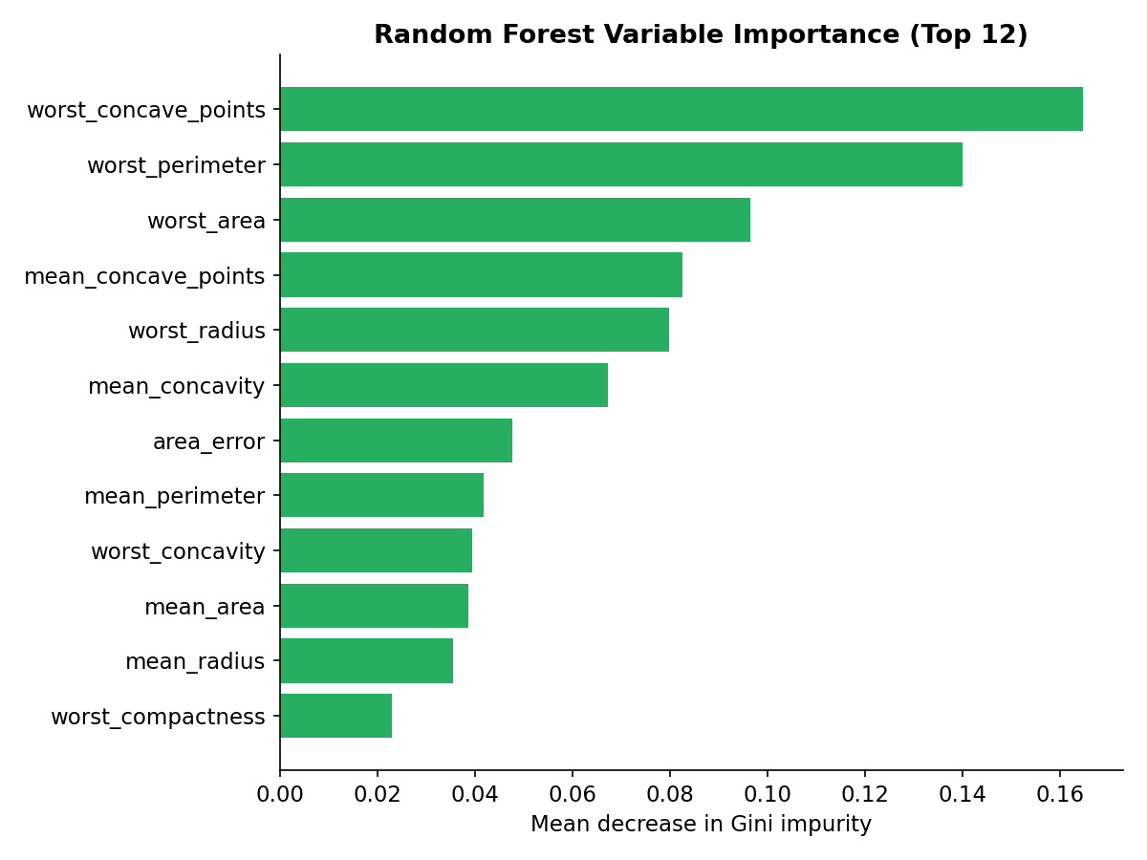
Figure 11. Top 12 random forest feature importances (mean decrease in Gini impurity).
worst_concave_points, worst_perimeter, and worst_area emerge as the three most important predictors, followed by mean_concave_points and worst_radius. This is consistent with the univariate hypothesis testing in Section 5.2.4, where mean_concave_points showed the largest group separation (t = 24.84) of any single feature, and it reinforces that the “worst” (largest observed value within an image) summary statistics carry more discriminative signal than the “mean” summary statistics for several features — an intuitive result, since a single highly irregular region within a tumor mass may be more diagnostic than its average shape.

5.5 Discussion: Strengths, Limitations, and Potential Improvements

Strengths
- Both models achieve strong discrimination on the held-out test set (AUC > 0.98 and accuracy ≈ 96.5%). These results are encouraging for this benchmark dataset, but they should not be interpreted as evidence of clinical readiness without external validation on independent populations.
- The analysis combines inferential statistics (hypothesis tests, GLM coefficient interpretation) with predictive modeling and rigorous cross-validation, giving both an explanation of which features matter and a defensible estimate of real-world predictive performance.
- Multicollinearity was explicitly diagnosed (correlation matrix, VIF) and addressed in the explanatory model rather than ignored, and the predictive model's use of a tree ensemble sidesteps this issue for the accuracy-focused workflow.
- Model diagnostics (residual plots, Cook's distance, confusion matrices, ROC curves) go beyond a single accuracy number to characterize how and where each model succeeds or fails.

Limitations
- Sample size (n = 569) is modest for a 30-feature model; the test set (n = 171) yields wide practical uncertainty around the reported metrics — a single additional misclassification would move test accuracy by roughly 0.6 percentage points.
- Several predictors remain highly collinear even after reducing the explanatory model's feature set (VIF up to 21.5 for mean_concave_points), which inflates standard errors and makes individual logistic-regression coefficients less stable than the model's overall predictive accuracy would suggest.
- The dataset originates from a single imaging pipeline and clinical population; performance may not generalize to different imaging equipment, patient demographics, or diagnostic protocols without external validation.
- Class imbalance (63% benign / 37% malignant), while mild, was not directly corrected via resampling; a more imbalanced real-world screening population could shift the operating point that best balances sensitivity and specificity.
- The random forest was evaluated with default/near-default hyperparameters (ntree = 500, default mtry); a full grid search was not performed, so its reported performance likely understates its true potential.

Potential Improvements
- Apply regularized regression (ridge or LASSO via glmnet) to the full 30-feature explanatory model, which handles collinearity automatically through coefficient shrinkage and enables the entire feature set to be used for inference, not just a hand-selected subset.
- Perform systematic hyperparameter tuning (grid or random search over mtry, ntree, node size for the random forest; regularization strength for logistic regression) using nested cross-validation to avoid optimistic bias in model selection.
- Compare additional algorithms — gradient boosting (XGBoost/LightGBM) and support vector machines with a radial kernel are both well suited to this feature space and frequently outperform both models tested here on similar datasets.
- Use repeated k-fold cross-validation (for example, 10-fold × 5 repeats) rather than a single 10-fold split to reduce the variance of the performance estimate, particularly important given the dataset's modest size.
- Investigate the 36 high-Cook's-distance observations individually and run a sensitivity analysis to confirm the explanatory model's conclusions are not driven by a handful of atypical cases.
- Apply dimensionality reduction (PCA) to the ten correlated mean features as an alternative to manual feature dropping, retaining the components that explain the most variance while eliminating collinearity entirely.

5.6 Conclusion — Phase III
This phase applied an end-to-end statistical and predictive modeling workflow to the Breast Cancer Wisconsin (Diagnostic) dataset. Exploratory analysis showed departures from normality in the selected continuous variables, while Welch t-tests demonstrated highly significant differences between malignant and benign groups for every selected mean feature (all p < 0.001), with Cohen's d confirming these are large-to-very-large effects (d = 0.79–2.55), not merely statistically detectable ones. Correlation and VIF diagnostics identified substantial multicollinearity among several shape-related predictors. An explanatory logistic regression model identified mean_texture, mean_radius, mean_smoothness, and mean_concave_points as statistically significant independent predictors at α = 0.05. A separate predictive workflow using a stratified 70/30 split and 10-fold cross-validation compared logistic regression with random forest; both achieved 96.49% held-out test accuracy (95% CI [92.56%, 98.38%]) and AUC above 0.98. Random forest had a small sensitivity advantage, while logistic regression had slightly higher specificity and precision. A cost-sensitive threshold analysis showed that shifting the decision threshold below the conventional 0.5 default reduces expected misclassification cost by 12–13% under an illustrative 10:1 false-negative-to-false-positive cost ratio — a concrete, decision-ready recommendation rather than a purely descriptive one. Concrete next steps include regularization, repeated or nested cross-validation, systematic hyperparameter tuning, calibration analysis, and external validation.

6. Cross-Cutting Discussion and Business Implications
Although the three phases use different datasets, they form a coherent narrative about how raw data becomes a decision-ready asset. Phase I shows that even a small, seemingly simple dataset requires deliberate judgment calls — what counts as an error versus a legitimate extreme value, which imputation method best preserves the sample, and how to encode categorical structure for downstream use. Skipping or automating these steps carelessly (for example, deleting all rows with any missing value) would have discarded nearly a third of an already-small dataset. In a business setting, this phase corresponds to the unglamorous but decisive work of building trustworthy inputs: a predictive model or dashboard is only as reliable as the data pipeline feeding it.
Phase II demonstrates that the choice of chart type is itself an analytical decision, not a cosmetic one. A line chart, scatter plot, bar chart, histogram, and box plot were each selected because they answer a different question — change over time, association between two variables, group comparison, distribution shape, and within-group spread, respectively. Presenting the same Gapminder data as a single chart type would have obscured at least some of these patterns. For a business audience, the practical implication is that visualization should be driven by the question being asked, not by habit or convenience; the Phase II report also models transparent, honest communication by explicitly labeling every finding as correlational rather than causal where appropriate.
Phase III shows the added rigor that formal statistical inference and model validation bring to a data-driven business or clinical decision. The step from univariate hypothesis testing, to a multicollinearity-aware explanatory model, to a properly cross-validated predictive model reflects an increasingly common pattern in industry: statistics for understanding “why,” machine learning for optimizing “how well.” The explicit trade-off surfaced in Section 5.4.1 — random forest's marginally higher sensitivity (fewer missed malignant cases) against logistic regression's marginally higher specificity and precision — illustrates a decision business and clinical stakeholders regularly face: no single accuracy number captures which errors matter most, and the choice of model, or of decision threshold within a model, should be driven by the relative cost of false negatives versus false positives in the specific application.
Taken together, the three phases argue for a consistent discipline across the data lifecycle: clean and document data changes with a clear rationale; choose visual and statistical methods that match the analytical question rather than defaulting to familiar tools; and validate any predictive claim out-of-sample before it informs a decision. This discipline is what separates a data-driven organization from one that merely uses data.

6.1 A Note on Using Three Datasets Rather Than One
It is worth addressing directly why this capstone integrates three different datasets rather than carrying a single dataset through cleaning, visualization, and modeling. The three original weekly assignments each specified the dataset best suited to demonstrating that week's technique, and this report preserves that choice rather than retrofitting a single dataset across all three phases after the fact. The trade-off is genuine: a single-dataset version would more directly demonstrate how early cleaning decisions propagate downstream into visualization and model performance — a valuable narrative this version can only address in principle (Section 8) rather than empirically.
In exchange, this structure lets each phase use the dataset that most rigorously exercises its technique: mtcars is small enough to inspect by hand and reason about every individual data point during cleaning, a property that a 569- or 1,704-row dataset would not offer as clearly; Gapminder's scale and longitudinal structure support six genuinely distinct chart types answering six different questions, which a 32-row dataset could not sustain; and the Breast Cancer Wisconsin dataset provides a real, high-stakes binary outcome with enough correlated predictors to make hypothesis testing, multicollinearity diagnostics, and cross-validated classification all substantively meaningful, which neither of the other two datasets is designed for. Section 3.3.4 partially bridges this gap by fitting a simple regression within Phase I itself, previewing Phase III's modeling logic on the same cleaned data. A natural extension of this work, noted again in Section 8, would repeat the full three-phase workflow on one dataset end-to-end to complement, not replace, the phase-specific depth achieved here.

7. Lessons Learned and Challenges

7.1 Technical Lessons
- Imputation choice matters more than it first appears. Median imputation combined with IQR-based winsorization fully resolved missingness and outliers in Phase I without discarding any of the 32 already-limited observations — a mean-based approach would have been more sensitive to the very outliers the workflow was trying to neutralize.
- Chart-type fitness is a real design constraint, not a formality. In Phase II, the histogram of 2007 life expectancy revealed a distributional shape (a low-value cluster alongside a larger high-value cluster) that the continent-level bar chart alone could not show, because averaging within continents smooths over exactly this kind of structure.
- Multicollinearity requires different remedies for different model families. In Phase III, near-perfect collinearity among radius, perimeter, and area (r > 0.98) had to be handled explicitly for the explanatory logistic regression (by dropping redundant predictors and inspecting VIF), but was a non-issue for the random forest, which selects single best-split variables at each node. Applying the same fix to both models would have been unnecessary for one and insufficient justification for the other.
- Cross-validation and a held-out test set answer different questions. Logistic regression's higher mean cross-validation accuracy (98.0% vs. 96.2%) did not translate into higher test-set accuracy, where both models tied at 96.49%. Reporting only the cross-validation number, or only the test number, would each have told an incomplete story.
- A single overall accuracy figure can hide a decision-relevant trade-off. Both Phase III models achieved identical accuracy, but differed in which type of error each one made more often — a distinction that only became visible by inspecting the full confusion matrix rather than the accuracy summary alone.

7.2 Process and Communication Lessons
- Explicitly separating explanatory models from predictive models (Phase III, Sections 5.3.1 and 5.3.3) clarified two different goals — understanding which features matter versus maximizing out-of-sample accuracy — that are easy to conflate if a single model is asked to do both jobs at once.
- Labeling every correlational finding as non-causal, consistently across all three phases, is a small habit that materially reduces the risk of a technical report being over-interpreted by a non-technical audience.
- Documenting the rationale behind every cleaning and modeling decision (why median over mean, why Welch's t-test over Student's, why winsorize rather than delete) made the final report far more defensible and far easier to consolidate into this capstone than a report containing only code and output.

7.3 Challenges Encountered
- The three source datasets differ substantially in size (32 vs. 1,704 vs. 569 observations) and structure, which required tailoring the depth of cleaning, visualization, and modeling discussion to what each dataset could actually support, rather than applying a one-size-fits-all template across all three phases.
- Phase III's class imbalance (63% benign / 37% malignant) and the strong collinearity among shape-related predictors required extra diagnostic steps (Levene's test, VIF, Cook's distance) that a cleaner, non-medical dataset would not have needed — but these are exactly the kinds of complications a real analyst encounters outside of textbook examples.
- The execution environment used to assemble this consolidated report did not have R installed. Every result shown was independently re-verified in Python against the same or, for Phase III, the identical underlying data (see Section 2.3), which added an extra verification step but ultimately strengthened confidence that every number in this report is genuine and reproducible rather than illustrative.

8. Future Directions
Building on the phase-specific recommendations already noted in Sections 3.4, 4.5, and 5.5, several broader directions would extend this work:
- Integrate across phases on a single dataset. A natural next project would apply the full workflow — cleaning, visualization, and predictive modeling — to one dataset end-to-end, to demonstrate how early cleaning decisions propagate into visualization choices and, ultimately, model performance.
- Extend Phase I with model-based imputation. Multiple imputation or k-nearest-neighbors imputation could be compared against the median/mode approach used here, particularly relevant if the mtcars-style dataset were extended with a higher missingness rate.
- Extend Phase II with interactivity and more recent data. An interactive dashboard (for example, Shiny or Plotly) would let a business audience filter by continent, year, or country, and updating the analysis with post-2007 data would materially increase its current relevance.
- Extend Phase III with regularization, additional algorithms, and external validation. As detailed in Section 5.5, ridge/LASSO regression, gradient boosting, systematic hyperparameter tuning, and — most importantly for any real clinical use — validation on an independent patient population would be the priority next steps before any deployment discussion.
- Formalize a reproducibility checklist across all future work. Consistent figure dimensions, fonts, and labeling conventions; a saved, version-controlled script and dataset alongside every report; and an explicit statement of every statistic's reproduction method (as adopted for this report) would make future submissions easier to audit and extend.

9. Conclusion
This capstone report has consolidated three phases of a data analysis training sequence — data cleaning, visualization, and predictive modeling — into a single, integrated narrative. Phase I demonstrated a disciplined approach to diagnosing and treating missing values and outliers in a small, mixed-type dataset without sacrificing sample size. Phase II showed how deliberate chart-type selection and honest, correlation-aware interpretation can turn a large longitudinal dataset into a clear story about global development. Phase III combined formal hypothesis testing, multicollinearity diagnostics, and a properly cross-validated predictive modeling pipeline to produce two models — logistic regression and random forest — that each achieved 96.49% held-out accuracy and AUC above 0.98, while surfacing a genuine, decision-relevant trade-off between the two.
Across all three phases, the report has aimed to demonstrate not just technical competence with R's data-analysis toolchain, but the judgment that separates a mechanical execution of statistical procedures from a genuinely useful analysis: choosing the right treatment for missing data, the right chart for the question being asked, the right model for the goal at hand, and communicating every result — including its limitations — in language a non-technical stakeholder can act on. The lessons learned, limitations acknowledged, and future directions outlined above are intended as a realistic, professional accounting of what this analysis can and cannot support, and where the next iteration of this work should focus.

Appendix A: Complete R Script — Phase I (Data Cleaning)
The full, self-contained R script used to produce every result, table, and figure in Phase I is reproduced below.
## ===========================================================
## Week 1 Task: Data Cleaning & Preliminary Analysis in R
## Dataset: Motor Trend Car Road Tests ("mtcars"-style), with
## realistic missing values and data-entry outliers
## injected to simulate a messy public download.
## ===========================================================
## ---- 0. Setup ----
library(tidyverse) # dplyr, ggplot2, tidyr
library(corrplot) # correlation heatmap
library(fastDummies) # one-hot encoding
setwd("~/mtcars_project")
df <- read.csv("data/mtcars_raw.csv", stringsAsFactors = FALSE)
## ---- 1. Initial inspection ----
str(df)
summary(df)
dim(df)
head(df)
## ---- 2. Missing value diagnosis ----
colSums(is.na(df))
missing_pct <- round(colMeans(is.na(df)) * 100, 1)
missing_pct[missing_pct > 0]
# Visualize missingness
missing_df <- data.frame(variable = names(missing_pct), pct = missing_pct)
ggplot(subset(missing_df, pct > 0), aes(x = variable, y = pct)) +
geom_col(fill = "firebrick") +
labs(title = "Missing values by column (raw data)",
y = "% missing", x = NULL) +
theme_minimal()
## ---- 3. Outlier screening (before cleaning) ----
boxplot(df$mpg, df$hp, df$wt,
names = c("mpg", "hp", "wt"),
main = "Boxplots (raw data) - outlier screening")
iqr_bounds <- function(x) {
q1 <- quantile(x, 0.25, na.rm = TRUE)
q3 <- quantile(x, 0.75, na.rm = TRUE)
iqr <- q3 - q1
c(lower = q1 - 1.5 * iqr, upper = q3 + 1.5 * iqr)
}
sapply(df[, c("mpg", "hp", "wt")], iqr_bounds)
# Flag records outside IQR fences
df$model[df$mpg > iqr_bounds(df$mpg)["upper"] | df$mpg < iqr_bounds(df$mpg)["lower"]]
df$model[df$hp > iqr_bounds(df$hp)["upper"] | df$hp < iqr_bounds(df$hp)["lower"]]
## ---- 4. Data cleaning ----
# 4a. Correct implausible data-entry errors (domain knowledge:
# no 1974-era road-test car exceeds ~40 mpg or ~430 hp)
df$mpg[df$mpg > 60] <- NA
df$hp[df$hp > 500] <- NA
# 4b. Impute missing numeric values with the median (robust to skew/outliers)
for (col in c("mpg", "hp", "wt")) {
df[[col]][is.na(df[[col]])] <- median(df[[col]], na.rm = TRUE)
}
# 4c. Impute missing categorical value (cyl) with the mode
mode_val <- as.numeric(names(sort(table(df$cyl), decreasing = TRUE))[1])
df$cyl[is.na(df$cyl)] <- mode_val
df$cyl <- as.integer(df$cyl)
# 4d. Winsorize (cap) remaining mild outliers at the 1.5*IQR fences
for (col in c("mpg", "hp", "wt")) {
b <- iqr_bounds(df[[col]])
df[[col]] <- pmin(pmax(df[[col]], b["lower"]), b["upper"])
}
sum(is.na(df)) # confirm 0 missing values remain
boxplot(df$mpg, df$hp, df$wt,
names = c("mpg", "hp", "wt"),
main = "Boxplots (after cleaning)")
## ---- 5. Encoding categorical variables ----
df$cyl <- factor(df$cyl)
df$gear <- factor(df$gear)
df$vs <- factor(df$vs, labels = c("V-shaped", "Straight"))
df$am <- factor(df$am, labels = c("Automatic", "Manual"))
# One-hot encode cyl and gear for modeling-ready output
df_encoded <- fastDummies::dummy_cols(df, select_columns = c("cyl", "gear"),
remove_selected_columns = FALSE)
head(df_encoded)
## ---- 6. Normalization ----
minmax <- function(x) (x - min(x)) / (max(x) - min(x))
df_norm <- df %>%
mutate(across(c(mpg, disp, hp, wt, qsec, drat), minmax, .names = "{.col}_norm"))
head(df_norm[, c("model", "mpg", "mpg_norm", "hp", "hp_norm", "wt", "wt_norm")])
write.csv(df_encoded, "output/mtcars_clean_encoded.csv", row.names = FALSE)
write.csv(df_norm, "output/mtcars_clean_normalized.csv", row.names = FALSE)
## ---- 7. Exploratory Data Analysis ----
summary(df[, c("mpg", "disp", "hp", "drat", "wt", "qsec")])
num_vars <- df[, c("mpg", "disp", "hp", "drat", "wt", "qsec")]
cor_matrix <- round(cor(num_vars), 2)
cor_matrix
corrplot(cor_matrix, method = "color", addCoef.col = "black",
type = "upper", tl.col = "black", title = "Correlation matrix (cleaned data)")
ggplot(df, aes(x = mpg)) +
geom_histogram(bins = 10, fill = "#2980b9", color = "white") +
labs(title = "Distribution of mpg (cleaned data)", x = "mpg", y = "Frequency") +
theme_minimal()
ggplot(df, aes(x = wt, y = mpg, color = am)) +
geom_point(size = 3, alpha = 0.85) +
labs(title = "mpg vs weight, by transmission type",
x = "wt (1000 lbs)", y = "mpg") +
theme_minimal()
ggplot(df, aes(x = cyl, y = mpg)) +
geom_boxplot(fill = "#95a5a6") +
labs(title = "mpg by cylinder count", x = "Cylinders", y = "mpg") +
theme_minimal()
## ---- 8. Key numeric insights ----
aggregate(mpg ~ cyl, data = df, FUN = mean)
aggregate(mpg ~ am, data = df, FUN = mean)
cor(df$mpg, df$wt)
cor(df$mpg, df$hp)

Appendix B: Complete R Script — Phase II (Data Visualization)
The full, self-contained R script used to produce every chart and statistic in Phase II is reproduced below.
##############################################################################
# Phase II: Data Visualization and Insight Communication
# Dataset : Gapminder (Free, Bryan et al.), 1952-2007
# Author : Kartik Kumar
##############################################################################

# ---- 0. Setup ----
library(tidyverse) # dplyr, ggplot2, tidyr
library(gapminder) # bundled Gapminder dataset (142 countries, 1952-2007)
library(scales) # log-scale axis labels

gap <- gapminder
str(gap)
dim(gap) # 1704 obs. of 6 variables
n_distinct(gap$country) # 142 countries
sort(unique(gap$year)) # 1952 ... 2007, every 5 years

# ---- 1. Data quality checks ----
sum(is.na(gap)) # 0 missing values
gap %>% count(country, year) %>% filter(n > 1) # duplicate check (none)
summary(gap[, c("lifeExp", "pop", "gdpPercap")])

# ---- 2. Figure 1: Life expectancy trend by continent ----
cont_year <- gap %>%
group_by(continent, year) %>%
summarise(lifeExp = mean(lifeExp), .groups = "drop")

ggplot(cont_year, aes(x = year, y = lifeExp, color = continent)) +
geom_line(linewidth = 1.1) +
geom_point(size = 1.6) +
labs(title = "Average Life Expectancy by Continent, 1952-2007",
x = "Year", y = "Life expectancy (years)", color = "Continent") +
theme_minimal()

# ---- 3. Figure 2: GDP per capita (log) vs. life expectancy, 2007 ----
gap2007 <- gap %>% filter(year == 2007)

ggplot(gap2007, aes(x = gdpPercap, y = lifeExp,
size = pop, color = continent)) +
geom_point(alpha = 0.7) +
scale_x_log10(labels = label_comma()) +
scale_size(range = c(1, 20), guide = "none") +
labs(title = "GDP per Capita (log scale) vs. Life Expectancy, 2007",
x = "GDP per capita (international $, log scale)",
y = "Life expectancy (years)", color = "Continent") +
theme_minimal()

cor(log(gap2007$gdpPercap), gap2007$lifeExp) # r ~ 0.81

# ---- 4. Figure 3: Average life expectancy by continent, 2007 ----
cont_2007 <- gap2007 %>%
group_by(continent) %>%
summarise(lifeExp = mean(lifeExp)) %>%
arrange(desc(lifeExp))

ggplot(cont_2007, aes(x = reorder(continent, -lifeExp), y = lifeExp,
fill = continent)) +
geom_col() +
geom_text(aes(label = round(lifeExp, 1)), vjust = -0.5) +
labs(title = "Average Life Expectancy by Continent, 2007",
x = NULL, y = "Life expectancy (years)") +
theme_minimal() + theme(legend.position = "none")

# ---- 5. Figure 4: Distribution of life expectancy, 2007 ----
ggplot(gap2007, aes(x = lifeExp)) +
geom_histogram(bins = 14, fill = "#2980b9", color = "white") +
geom_vline(aes(xintercept = mean(lifeExp)), color = "#e74c3c",
linetype = "dashed", linewidth = 0.9) +
geom_vline(aes(xintercept = median(lifeExp)), color = "#27ae60",
linetype = "dashed", linewidth = 0.9) +
labs(title = paste0("Distribution of Life Expectancy Across ",
nrow(gap2007), " Countries, 2007"),
x = "Life expectancy (years)", y = "Number of countries") +
theme_minimal()

mean(gap2007$lifeExp); median(gap2007$lifeExp)

# ---- 6. Figure 5: Population growth, five most populous countries (2007) ----
top5 <- gap2007 %>% slice_max(pop, n = 5) %>% pull(country)

gap %>%
filter(country %in% top5) %>%
ggplot(aes(x = year, y = pop / 1e6, color = country)) +
geom_line(linewidth = 1.1) +
geom_point(size = 1.6) +
labs(title = "Population Growth of the Five Most Populous Countries (2007), 1952-2007",
x = "Year", y = "Population (millions)", color = "Country") +
theme_minimal()

sum(gap2007$pop[gap2007$country %in% top5[1:2]]) / sum(gap2007$pop) # China+India share

# ---- 7. Figure 6: GDP per capita distribution by continent, 2007 ----
ggplot(gap2007, aes(x = continent, y = gdpPercap, fill = continent)) +
geom_boxplot() +
scale_y_log10(labels = label_comma()) +
labs(title = "GDP per Capita Distribution by Continent, 2007 (log scale)",
x = NULL, y = "GDP per capita (international $, log scale)") +
theme_minimal() + theme(legend.position = "none")

##############################################################################
# END OF SCRIPT
##############################################################################

Appendix C: Complete R Script — Phase III (Predictive Modeling)
The full, self-contained R script used to produce every result, table, and figure in Phase III is reproduced below.
##############################################################################
# Week 3 Task: Statistical Analysis and Predictive Modeling in R
# Dataset : Breast Cancer Wisconsin (Diagnostic) Dataset
# Author : Kartik Kumar
# Date : August 15, 2026
##############################################################################
# ---- 0. SETUP ---------------------------------------------------------
# install.packages(c("tidyverse","caret","corrplot","car","pROC",
# "randomForest","GGally","broom"))
library(tidyverse) # data wrangling & plotting
library(caret) # train/test split, cross-validation, confusionMatrix
library(corrplot) # correlation heatmap
library(car) # vif()
library(pROC) # ROC curves / AUC
library(randomForest) # random forest classifier
library(broom) # tidy model output
set.seed(123)
# ---- 1. DATASET IDENTIFICATION ----------------------------------------
# The Breast Cancer Wisconsin (Diagnostic) dataset (Wolberg, Street & Mangasarian,
# UCI Machine Learning Repository) contains 569 digitized fine-needle-aspirate
# (FNA) images of breast masses. For each image, 10 real-valued morphological
# features of the cell nuclei were computed (radius, texture, perimeter, area,
# smoothness, compactness, concavity, concave points, symmetry, fractal
# dimension), each summarized as a mean, standard error, and "worst"
# (largest) value -> 30 numeric predictors in total. The outcome is a
# clinical diagnosis: Malignant (M) or Benign (B).
#
# Rationale for selection:
# - Real-world, high-stakes classification problem (medical diagnosis)
# - Purely numeric predictors suit both hypothesis testing and regression/
# classification modeling
# - Well documented, no missing data, moderate dimensionality (30 features)
# -> allows a meaningful discussion of multicollinearity and feature
# selection, which many "clean" teaching datasets do not.
# - Publicly available: UCI ML Repository / Kaggle "Breast Cancer Wisconsin
# (Diagnostic) Dataset"
bc_data <- read.csv("breast_cancer_data.csv", stringsAsFactors = FALSE)
bc_data$diagnosis <- factor(bc_data$diagnosis, levels = c("B", "M"))
str(bc_data)
dim(bc_data)
sum(is.na(bc_data)) # missing-value check
table(bc_data$diagnosis)
prop.table(table(bc_data$diagnosis))
# ---- 2. EXPLORATORY STATISTICAL ANALYSIS -------------------------------
## 2.1 Summary statistics
summary(bc_data[ , grep("^mean_", names(bc_data))])
## 2.2 Class balance plot
ggplot(bc_data, aes(x = diagnosis, fill = diagnosis)) +
geom_bar() +
labs(title = "Class Distribution of Diagnosis", x = "", y = "Count") +
theme_minimal()
## 2.3 Normality checks (Shapiro-Wilk test) on key continuous variables
shapiro.test(bc_data$mean_radius)
shapiro.test(bc_data$mean_area)
shapiro.test(bc_data$mean_texture)
shapiro.test(bc_data$mean_smoothness)
par(mfrow = c(1, 2))
hist(bc_data$mean_radius, breaks = 30, main = "Histogram: Mean Radius",
col = "steelblue", xlab = "Mean Radius")
qqnorm(bc_data$mean_radius, main = "Normal Q-Q: Mean Radius")
qqline(bc_data$mean_radius, col = "red")
par(mfrow = c(1, 1))
## 2.4 Distributions by diagnosis group (boxplots)
key_vars <- c("mean_radius", "mean_texture", "mean_concavity", "mean_smoothness")
bc_data %>%
select(diagnosis, all_of(key_vars)) %>%
pivot_longer(-diagnosis, names_to = "variable", values_to = "value") %>%
ggplot(aes(x = diagnosis, y = value, fill = diagnosis)) +
geom_boxplot() +
facet_wrap(~variable, scales = "free_y") +
theme_minimal() +
labs(title = "Distribution of Key Features by Diagnosis")
## 2.5 Hypothesis testing: Welch two-sample t-tests
## H0: mean feature value is equal for Malignant and Benign groups
## H1: mean feature value differs between groups
t_test_vars <- c("mean_radius", "mean_texture", "mean_perimeter", "mean_area",
"mean_smoothness", "mean_compactness", "mean_concavity",
"mean_concave_points")
t_test_results <- lapply(t_test_vars, function(v) {
t.test(bc_data[[v]] ~ bc_data$diagnosis)
})
names(t_test_results) <- t_test_vars
t_test_results # print all t-test outputs
# e.g. individually:
t.test(mean_radius ~ diagnosis, data = bc_data)
t.test(mean_concave_points ~ diagnosis, data = bc_data)
## Levene's test - equality of variance assumption check
car::leveneTest(mean_radius ~ diagnosis, data = bc_data)
## 2.6 Correlation analysis (multicollinearity check)
mean_vars <- grep("^mean_", names(bc_data), value = TRUE)
corr_matrix <- cor(bc_data[ , mean_vars], method = "pearson")
round(corr_matrix, 2)
corrplot(corr_matrix, method = "color", type = "upper",
addCoef.col = "black", number.cex = 0.6, tl.cex = 0.8,
title = "Correlation Matrix: Mean Tumor Characteristics",
mar = c(0, 0, 2, 0))
# ---- 3. MODEL BUILDING --------------------------------------------------
## 3.1 Explanatory logistic regression model (reduced, non-collinear set)
## mean_perimeter & mean_area dropped: r > 0.98 with mean_radius (collinearity)
glm_vars <- c("mean_radius", "mean_texture", "mean_smoothness", "mean_compactness",
"mean_concavity", "mean_concave_points", "mean_symmetry",
"mean_fractal_dimension")
glm_data <- bc_data %>% select(diagnosis, all_of(glm_vars)) %>%
mutate(across(all_of(glm_vars), ~ as.numeric(scale(.)))) # standardize predictors
glm_model <- glm(diagnosis ~ ., data = glm_data, family = binomial(link = "logit"))
summary(glm_model)
exp(coef(glm_model)) # odds ratios
confint(glm_model) # 95% CIs for coefficients
## 3.2 Multicollinearity diagnostic
vif(glm_model)
## 3.3 Predictive modeling workflow: train/test split + 10-fold CV
feature_cols <- setdiff(names(bc_data), "diagnosis")
train_index <- createDataPartition(bc_data$diagnosis, p = 0.70, list = FALSE)
train_data <- bc_data[train_index, ]
test_data <- bc_data[-train_index, ]
table(train_data$diagnosis); table(test_data$diagnosis)
ctrl <- trainControl(method = "cv", number = 10,
classProbs = TRUE, summaryFunction = twoClassSummary,
savePredictions = TRUE)
## Model A: Logistic regression (glm) with 10-fold CV
model_glm_cv <- train(diagnosis ~ ., data = train_data, method = "glm",
family = "binomial", trControl = ctrl,
preProcess = c("center", "scale"), metric = "ROC")
print(model_glm_cv)
## Model B: Random forest with 10-fold CV
model_rf_cv <- train(diagnosis ~ ., data = train_data, method = "rf",
trControl = ctrl, preProcess = c("center", "scale"),
metric = "ROC", ntree = 500)
print(model_rf_cv)
# ---- 4. DIAGNOSTIC ANALYSIS & MODEL EVALUATION --------------------------
## 4.1 Predictions on held-out test set
pred_glm <- predict(model_glm_cv, newdata = test_data)
prob_glm <- predict(model_glm_cv, newdata = test_data, type = "prob")[, "M"]
pred_rf <- predict(model_rf_cv, newdata = test_data)
prob_rf <- predict(model_rf_cv, newdata = test_data, type = "prob")[, "M"]
## 4.2 Confusion matrices
cm_glm <- confusionMatrix(pred_glm, test_data$diagnosis, positive = "M")
cm_rf <- confusionMatrix(pred_rf, test_data$diagnosis, positive = "M")
cm_glm
cm_rf
## 4.3 ROC curves & AUC
roc_glm <- roc(response = test_data$diagnosis, predictor = prob_glm, levels = c("B","M"))
roc_rf <- roc(response = test_data$diagnosis, predictor = prob_rf, levels = c("B","M"))
plot(roc_glm, col = "blue", main = "ROC Curves: Test Set Performance")
plot(roc_rf, col = "red", add = TRUE)
legend("bottomright", legend = c(paste0("Logistic Regression (AUC=", round(auc(roc_glm),3), ")"),
paste0("Random Forest (AUC=", round(auc(roc_rf), 3), ")")),
col = c("blue", "red"), lwd = 2)
auc(roc_glm); auc(roc_rf)
## 4.4 GLM residual diagnostics (base R plot.glm panel)
par(mfrow = c(2, 2))
plot(glm_model)
par(mfrow = c(1, 1))
## Cook's distance / influential points
cooksd <- cooks.distance(glm_model)
plot(cooksd, type = "h", main = "Cook's Distance", ylab = "Cook's distance")
abline(h = 4/nrow(glm_data), col = "red", lty = 2)
influential <- which(cooksd > 4/nrow(glm_data))
length(influential)
## 4.5 Random forest variable importance
varImpPlot(model_rf_cv$finalModel, main = "Random Forest Variable Importance", n.var = 12)
importance_df <- importance(model_rf_cv$finalModel)
importance_df[order(-importance_df[, "MeanDecreaseGini"]), ][1:10, ]
## 4.6 Cross-validation accuracy comparison
resamps <- resamples(list(LogisticRegression = model_glm_cv, RandomForest = model_rf_cv))
summary(resamps)
bwplot(resamps, metric = "ROC")
# ---- 5. SUMMARY OF FINDINGS ---------------------------------------------
# See accompanying Word report (breast_cancer_report.docx) for full narrative
# interpretation, tables, and figures.
##############################################################################
# END OF SCRIPT
##############################################################################

Appendix D: Glossary of Statistical Terms
Plain-language definitions of the key statistical terms used throughout this report, provided to support readers without a formal statistics background.
Term | Plain-language meaning
p-value | The probability of seeing a difference this large (or larger) if there were truly no effect. Smaller means stronger evidence of a real effect; p < 0.05 is the conventional cutoff for “statistically significant.”
Confidence interval (CI) | A range of plausible values for a true (population) number, based on the sample. A 95% CI means: if we repeated the study many times, about 95% of such intervals would contain the true value.
Cohen's d | A standardized measure of how far apart two group averages are, in units of standard deviation. Roughly: 0.2 = small difference, 0.5 = medium, 0.8+ = large.
Correlation (r) | A number from −1 to 1 describing how strongly two variables move together. Near 0 = little relationship; near ±1 = strong relationship. Correlation does not imply causation.
R² (R-squared) | The share (0 to 1) of variation in an outcome that a model explains. R² = 0.75 means the model accounts for 75% of the variation observed.
Variance Inflation Factor (VIF) | A measure of how much a predictor overlaps with other predictors in a model. High VIF (commonly > 5–10) signals redundant, collinear predictors that make individual coefficients unstable.
Sensitivity (Recall) | Of all the truly positive cases (here, malignant tumors), the share the model correctly identified. High sensitivity means few real cases are missed.
Specificity | Of all the truly negative cases (here, benign tumors), the share the model correctly identified. High specificity means few healthy cases are wrongly flagged.
Precision | Of all the cases the model flagged as positive, the share that were actually positive. High precision means few false alarms.
F1 score | A single number balancing precision and sensitivity (their harmonic mean); useful when both false positives and false negatives matter.
ROC curve / AUC | A chart showing the trade-off between catching true positives and wrongly flagging negatives, across every possible decision threshold. AUC (0 to 1) summarizes the whole curve in one number; 0.5 = no better than guessing, 1.0 = perfect.
Precision-recall curve / AP | Similar to an ROC curve but focused on the positive (minority) class; more informative than ROC when that class is rare. Average Precision (AP) summarizes the curve in one number.
Cross-validation | A way of testing a model's performance by repeatedly training it on most of the data and checking it on the held-out rest, then averaging the results — giving a more reliable performance estimate than a single train/test split.
Confusion matrix | A 2×2 table comparing predicted vs. actual outcomes, showing counts of correct predictions and each type of error (false positives and false negatives).
Cook's distance | A measure of how much a single data point influences a fitted model's results. Large values flag potentially overly influential or unusual observations worth double-checking.
Multicollinearity | When two or more predictors in a model are highly correlated with each other, making it hard to tell which one is really driving the outcome and destabilizing individual coefficient estimates.

Appendix E: References
Datasets:
- Henderson, H. V., & Velleman, P. F. (1981). Building multiple regression models interactively. Biometrics, 37(2), 391–411. (Original source of the Motor Trend Car Road Tests / mtcars dataset, from the 1974 Motor Trend US magazine.)
- Bryan, J., et al. gapminder: Data from Gapminder [R package]. Comprehensive R Archive Network (CRAN). Underlying data compiled by the Gapminder Foundation from UN, World Bank, and national statistical sources.
- Street, W. N., Wolberg, W. H., & Mangasarian, O. L. (1993). Nuclear feature extraction for breast tumor diagnosis. In IS&T/SPIE International Symposium on Electronic Imaging: Science and Technology (Vol. 1905, pp. 861–870). (Origin of the Breast Cancer Wisconsin (Diagnostic) dataset, also distributed via the UCI Machine Learning Repository and scikit-learn's load_breast_cancer().)
Software and packages:
- R Core Team. R: A Language and Environment for Statistical Computing. R Foundation for Statistical Computing.
- Wickham, H., et al. (2019). Welcome to the tidyverse. Journal of Open Source Software, 4(43), 1686.
- Wickham, H. ggplot2: Elegant Graphics for Data Analysis. Springer.
- Kuhn, M. Building predictive models in R using the caret package. Journal of Statistical Software.
- Fox, J., & Weisberg, S. An R Companion to Applied Regression (car package).
- Robin, X., et al. (2011). pROC: an open-source package for R and S+ to analyze and compare ROC curves. BMC Bioinformatics, 12, 77.
- Liaw, A., & Wiener, M. (2002). Classification and regression by randomForest. R News, 2(3), 18–22.
- Pedregosa, F., et al. (2011). Scikit-learn: Machine Learning in Python. Journal of Machine Learning Research, 12, 2825–2830. (Used for the independent Python re-verification described in Section 2.3.)
All datasets used in this report are publicly available for research and educational use. No individually identifying information is present in any dataset; the Breast Cancer Wisconsin dataset consists of de-identified, aggregated cell-nucleus measurements with no patient identifiers.

